Market Day
Pipe Creek Presbyterian Church
Saturday September 25, 2021 9am-3pm
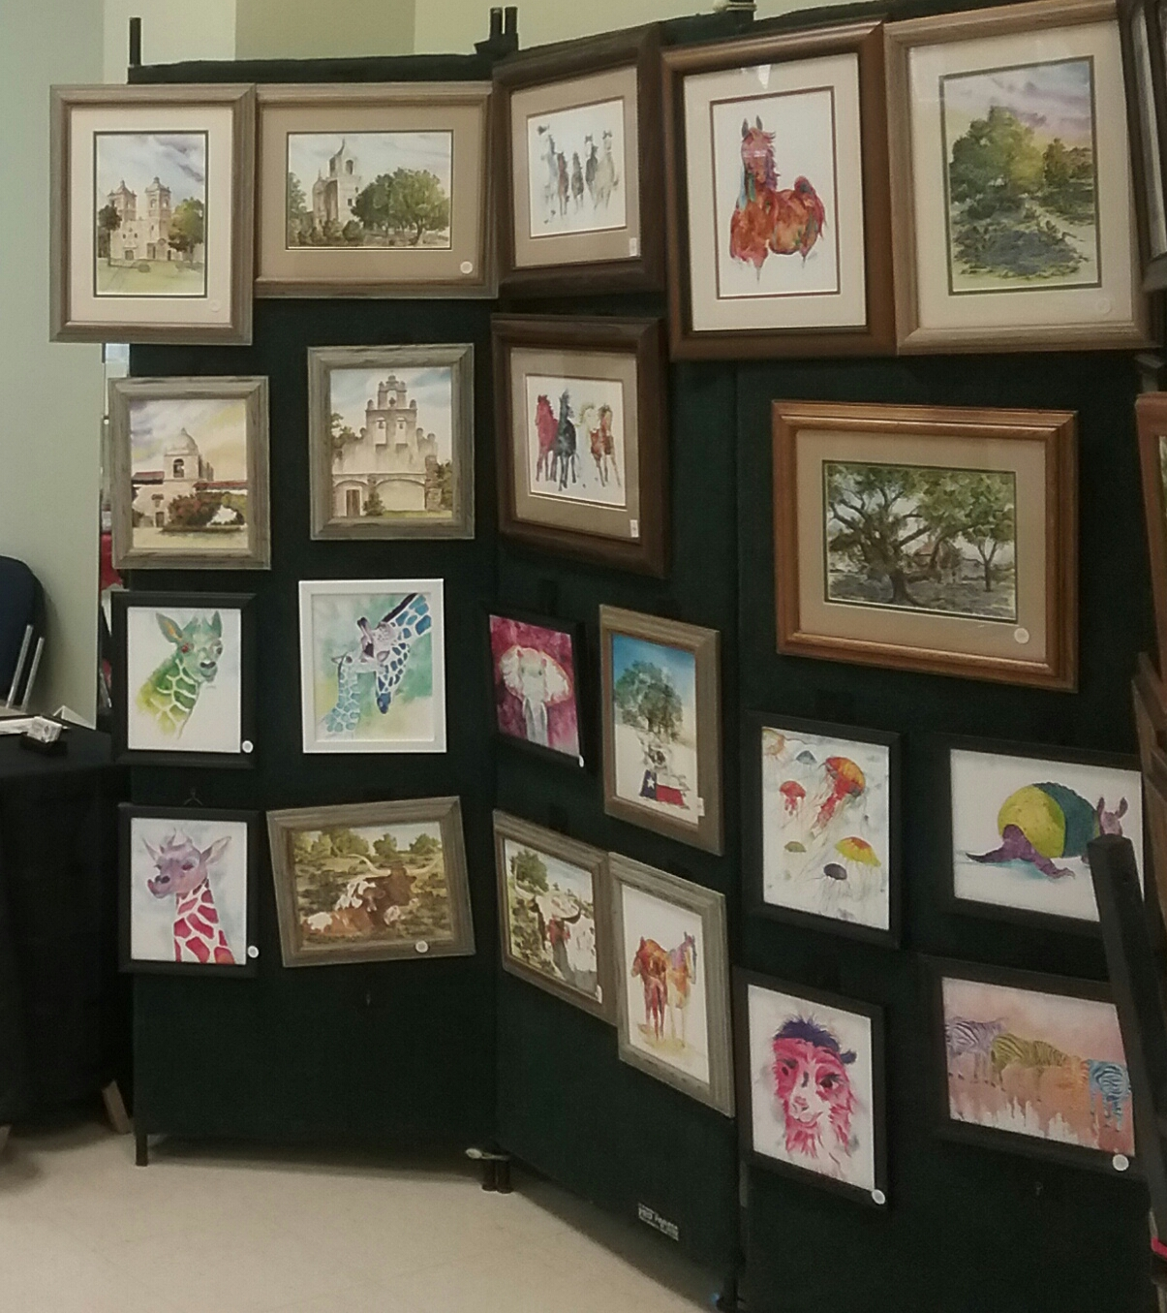

--Selection of pictures from some of previous years’ vendors
Pipe Creek Presbyterian Church 8589 Hwy 16 S., Pipe Creek - Some of the best Texas artists (many handmade items, greeting cards, jams and jellies, soaps, candles, baby items, jewelry) and small businesses (Pampered Chef, Jewelry, Papparazzi, Lipsence, 31 Gifts, Scentsy, and more) lunch, quilt raffle, and bake sale.

Come picnic and shop with us!

