July 2022

PIPE CREEK PIPELINE
News, notes, and updates about our church family
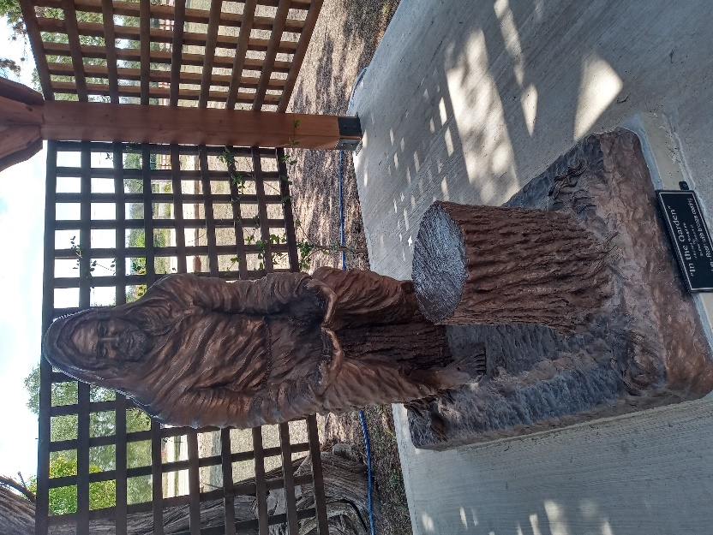
From the Pastor’s Pen…
July offers a variety of activities including worship, celebration, and fellowship. The first weekend of July, as usual, is the time for us to celebrate our Nation’s Freedom! Hopefully part of our celebration will include time to realize all of the great gifts God provides us! We are truly blessed! On July 9th we will have a “garage sale”, please look for the details on page 7 in this Pipeline. We will gather as a church family on Saturday, July 23rd to celebrate and remember Bonnie Westley’s life. We will participate with other churches and the Hill Country Samaritans in the Back-to-School Bash on Saturday, July 30, from 4:30 – 7:30p at the Lakehills Community Center. This is a great day to see smiles on children’s faces as we help them prepare to begin a new school year. Our role is to offer God’s blessings that they can take with them each day of the school year.
Come and be a part of the excitement of our church’s life. There are many opportunities for worship and fellowship that will make your summer enjoyable. God be with you and your family always!
Pastor Duane Manning

8589 Highway 16 South, P.O. Box 63377, Pipe Creek TX 78063 830-510-6650
Sunday School 9:30 am Worship 10:30 am

JULY SCRIPTURE PASSAGES
July 3 – Psalm 30; Luke 10: 1 – 11, 16 - 20

July 10 – Colossians 1: 1 – 14; Luke 10: 25 – 37

July 17 – Psalm 15; Luke 10: 38 - 42

July 24 – Psalm 85; Luke 11: 1 – 13

July 31 – Psalm 107: 1 – 9, 43; Luke 12: 13 - 21

Theme for the Month: Faithful Living
Throughout July a main theme might be “Travel”. Jesus sends out 70 people to share the good news while depending on the hospitality of everyone they meet. On July 10th we read the familiar story of the Good Samaritan. Let’s gather for worship and see what “new” message God has for us. The theme for the last three Sundays might be “God’s Blessings”. As we read from the Gospel of Luke, we are reminded to “keep the main thing, the main thing”; “ask, seek, and knock”; and “you can’t take it with you”. Come and worship with your church family while we learn from God’s Word together. Let’s continue our summer by gathering for worship and fellowship as we become the Church God has planned for us to be! Peace & Blessings. Duane Manning

LUNCH BUNCH MEETS IN JULY
July sees the Lunch Bunch gathering at Bricks River Café on July 8 at noon. Bricks is located at 1205 Main Street, Bandera. Sign up at the table in Fellowship Hall to join the fun, enjoy the fellowship, and taste the good food offered at one of our finest restaurants.

For your future planning, Lunch Bunch will gather each month at a restaurant nearby. If you would like to suggest a restaurant for the group to try, contact Barbara Boalo at 830-328-8009.
2
JULY BIRTHDAYS ANNIVERSARIES
7/1 Barbara Maxwell 7/4 Duane & Jackie Manning
7/2 Barbara Boalo 7/20 Gerhard & Charlotte Retief
7/3 Duane Manning Don & Terri Haga
7/4 Sharon Cortes 7/28 Stephen & Ashley Weller
7/5 Harry Maxwell
7/6 Laurie Williams
7/7 Ryeth Rasmussen
7/18 Ian MacDonald
7/19 Yoli Sollinger
Martika Duperault

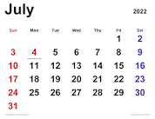
CALENDAR OF EVENTS, JULY
Jul 8 Lunch Bunch, Bricks, Bandera
Jul 9 Church-wide Yard Sale, PCPC
Jul 23 Bonnie Westley Memorial
Service
Jul 24 Session Meeting
Jul 30 Back-to-School Bash, Lakehills

3
DIRECTORY UPDATE:
Margo Begy announced that she was moving in July to North Carolina. Her new address will be 800 Melrose Street, Winston-Salem, NC 27103.

FROM THE QUILTING MINISTRY…
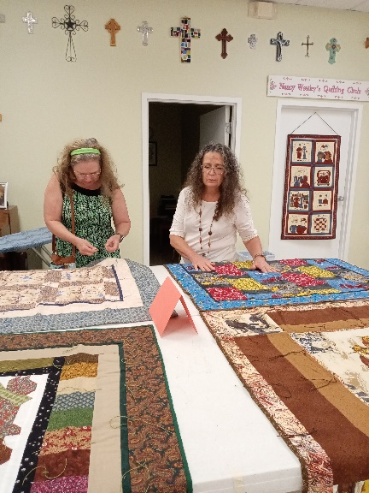
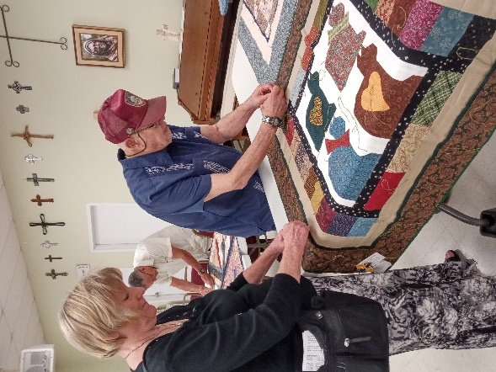

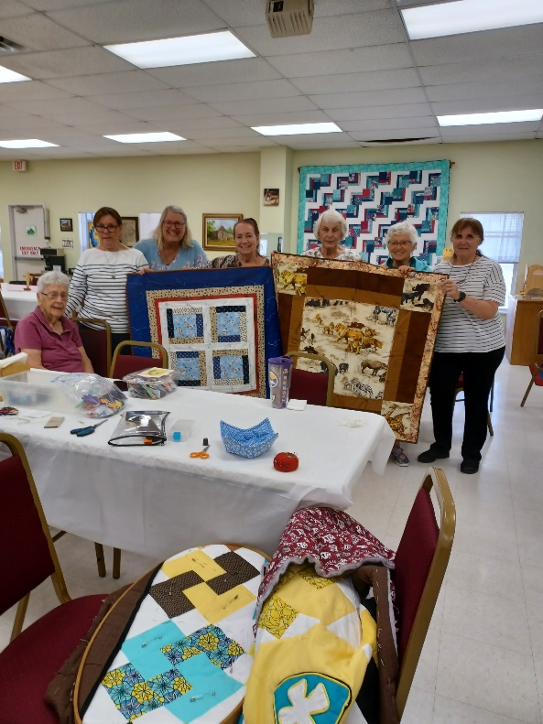
Valerie Hannah was contacted by the Quilters Guild from Uvalde asking if PCPC’s quilters would be interested in providing quilts to the siblings of the children killed at the Robb Elementary School. “Yes, absolutely” was the reply! Valerie and Barbara Boalo selected 10 quilts which were presented to the congregation to have their strings tied and be prayed over. The quilts were then taken to Gone Quiltin’ in Bandera which took them to Uvalde. Let’s continue to hold Uvalde’s families in our hearts and prayers.

4
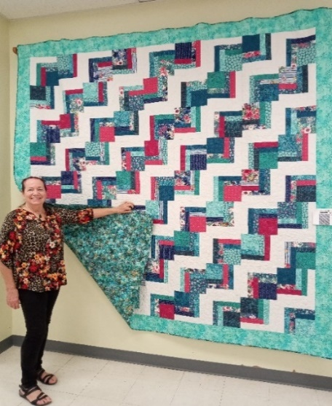
Dori Duperault is standing beside the quilt she made which will be auctioned at our fall Market Day in September or October ($5 a ticket from any of the quilters). Dori loves to quilt and shared these details about this beautiful one: She spent about 60 – 70 hours working on it in December and then a little in January and February. She did the cutting and color placement to make the design appealing to the eye, then the other Monday quilters helped with the layout of the blocks. After sewing the blocks together, Elaine Weller and Barbara Boalo helped choose the border and backing, and Rose Jeter finished it by doing the quilting. Don’t miss out on your opportunity to own this beautiful king size quilt!!

A THANK YOU: Dear Ladies, Thank you for the beautiful prayer quilt and pot holders. It means so much to me to know I have such sweet and devoted prayer warriors praying for me. You have really brought a lot of sunshine into my life.
Linda Smith, Andalusia, Alabama

A CAMPIN’ WE WILL GO!!
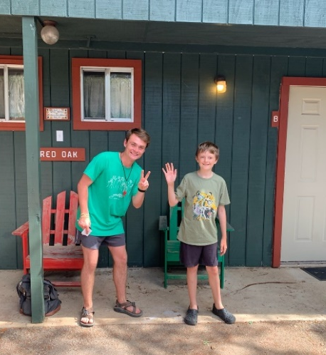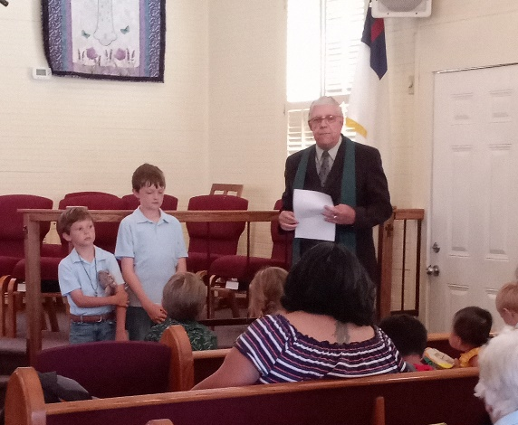
Pastor Duane, in the photo on the right, is seen commissioning Egan and Tesher Weller as they prepare to go to John Knox Camp on June 20. On the left, Tesher is meeting his camp counselor and is getting ready to experience church camp for the first time.
5
CHURCH GARAGE SALE, JULY 9, 9:00AM -- ??
Do you have items collecting dust that you’d like to sell? Price your items and bring them to the church before July 9th for a garage sale. If it’s just a few items, you can use a table and set up inside Fellowship Hall. If you have a lot, set up outside.
We will advertise on Facebook so expect a lot of shoppers. Don’t forget to bring change! Yes, you have to attend to sell your treasures. And, yes, whatever’s not sold still belongs to you – you have to take it with you to dispose of it!
Questions? Contact Chris Kelley at 210-391-1629.

7

