June 2022

PIPE CREEK PIPELINE
News, notes, and updates about our church family

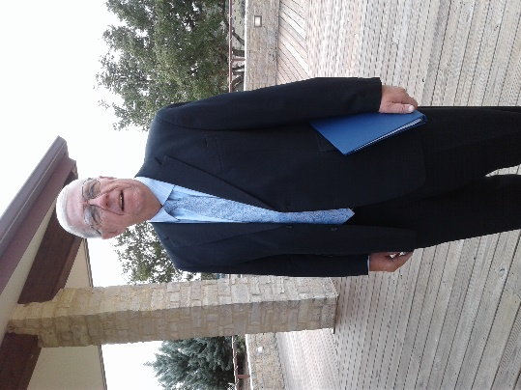
From the Pastor’s Pen…
Every Sunday is special! June 2022 is a great example of that thought. The first Sunday in June is Pentecost Sunday, the birthday of the Church! We’re going to have a great month when we begin with the Holy Spirit blowing in our lives! The second Sunday is Trinity Sunday! We will gather for worship in the name of the Father, Son, and Holy Spirit. The third Sunday is Father’s Day, and we will remember those special men who brought us into this world. The last Sunday in June we will Baptize Sibby and Rick’s grandsons, Tommy and Michael Joseph. We welcome these two children into our church family. Come and be a part of the excitement of our church’s life. There are many opportunities for worship and fellowship that will make your summer enjoyable. God be with you and your family always!
Pastor Duane Manning

8589 Highway 16 South, P.O. Box 63377, Pipe Creek TX 78063 830-510-6650
Sunday School 9:30 am Worship 10:30 am

JUNE SCRIPTURE READINGS
June 5 - Pentecost – Psalm 104: 24 – 34, 35b; Acts 2: 1 - 21

June 12 – Psalm 8; John 16: 12 - 15

June 19 – Father’s Day – Psalm 22: 19 – 28; Luke 8: 26 - 39

June 26 – Psalm 16; Luke 9: 51 - 62

Theme for the Month: Led by the Spirit

June begins with the Day of Pentecost. We read in the Book of Acts the story of the Holy Spirit coming from Heaven to lead God’s people. Peter reminds his fellow disciples that the prophecy of Joel is occurring. On June 19th, we celebrate Father’s Day and also see how Jesus heals a man possessed by demons. Jesus reminds us to proclaim the great things done by the Father. The last Sunday is the story of Jesus being rejected by the Samaritans. People say they are willing to follow Jesus after they take care of other matters. As we begin our summer, let’s remember we’re led by the Holy Spirit as we proclaim all of the great things God has done for us. Let’s gather for worship and fellowship as we become the Church God has planned for us to be! Peace & Blessings. Duane Manning

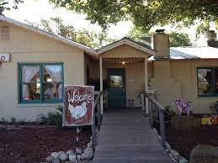
LUNCH BUNCH MEETS IN JUNE
June again sees the Lunch Bunch gathering at the Backyard Bistro on June 11 at noon. The Bistro, always a Pipe Creek favorite, is located at 167 Panther Ridge in Pipe Creek, on the corner of Panther Ridge and Hwy 16. Sign up at the table in Fellowship Hall to join the fun, enjoy the fellowship, and taste the good food offered at one of our finest restaurants.

For your future planning, Lunch Bunch will gather each month at a restaurant nearby. If you would like to suggest a restaurant for the group to try, contact Barbara Boalo at 830-328-8009.
2
JUNE BIRTHDAYS ANNIVERSARIES
6/1 Jena Kraemer 6/6 Delmar & Mary Potter
6/2 Norine Chamberlain 6/12 Ralph & Ruth Woodhull
6/4 Elaine Weller 6/13 Thomas & Jena Kraemer
6/5 Robert MacDonald
6/6 Jim Chenault
6/9 Dori Duperault
6/11 Tom Cortes
6/15 Sandi (Chase) Sherman
6/16 Warner Hord
6/21 Thomas Kraemer
6/26 Gail Hord
6/28 Bristol Kraemer

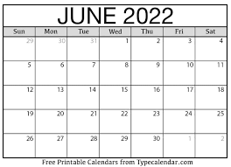

CALENDAR OF EVENTS, JUNE
5 Pentecost Sunday, wear red!
10 Lunch Bunch, Backyard Bistro, noon
12 Session Meeting
19 Father’s Day

3
PATSY SMALL MEMORIAL LIBRARY IS DEDICATED AT BANDERA HIGH SCHOOL
Ever notice that PCPC’s library is the Patsy Small Library? Not only was Patsy PCPC’s librarian, she worked tirelessly within the BISD system to staff and make BISD’s libraries ‘state of the art.’ She was celebrated and remembered at a dedication ceremony at the Bandera High School on May 26. Patsy was a native of San Antonio who married Eddie Small and traveled with him during his Naval career. She and Eddie purchased a homestead in Bandera county and started a family. In 1985 Patsy became the middle and high school librarian for Bandera ISD. Her ‘dream job’ of district librarian for Bandera ISD opened up -- she immediately applied and was hired. Patsy’s legacy is reflected in the way libraries were run with the advent of technology and her advocacy for the literacy of the children of BISD.

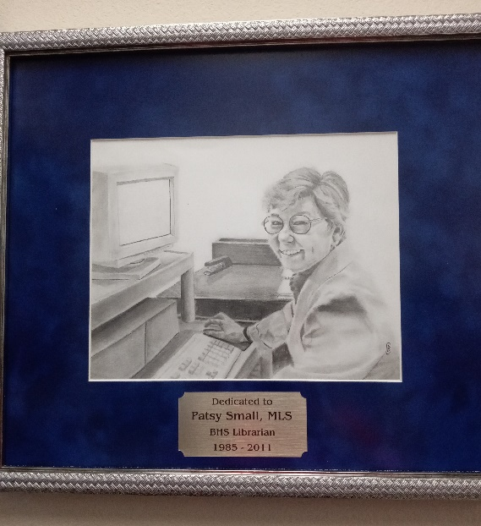
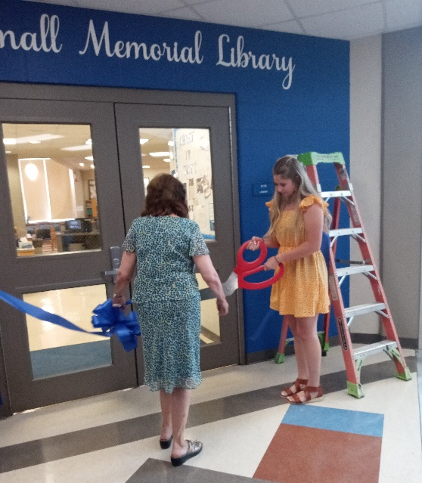

Above, granddaughter Lyndsay Blair is cutting the ribbon of the re-named library. To the right, a remarkable senior Bandera High School artist, Braden Cox, shows Patsy at her computer.

NOTARY SERVICES:
These folks are Notaries and are available if you need their services:
Barbara Maxwell, cell 732-600-2221
Jackie Manning, cell 830-456-7086
4
SUMMERTIME, AND THE LIVING IS…..HOT!!!!
Well, our thermometer hit the 100 mark already this year, so it seems that summer has arrived in south Texas! I know, I know, the calendar says differently, but I know heat when I feel it. So, let’s just review… how do we stay healthy and well in the (very) warm weather?
Three things to keep in mind as the temperatures rise:
Most importantly of all – be sure to keep well- hydrated! Water, seltzer, juices, did I say water? All of these can help keep your body hydrated. Drink more fluids than you usually do, regardless of how active you are. Don’t wait until you’re thirsty to drink. You need to get ahead of this, and keep your body “well-watered”.
However, one warning - If your doctor has limited the amount you drink or has you on water pills, be sure to ask him/her how much you should drink while the weather is hot.
Stay away from very sugary or alcoholic drinks—These actually cause you to lose more body fluid. Also, avoid very cold drinks, because they can cause stomach cramps.
Replace Salt and Minerals - Heavy sweating removes salt and minerals from the body that need to be replaced. A sports drink can replace the salt and minerals you lose in sweat. But, again, If you are on a low-salt diet, have diabetes, high blood pressure, or other chronic conditions, talk with your doctor before drinking a sports beverage or taking salt tablets to be sure she/he feels this is advisable for YOU. A good time to discuss this with your physician is, well, NOW, before the heavy heat is here. You don’t want to be calling the doctor’s office at the last minute when the temperatures are sky high, only to find that your doctor is on vacation!
Keep Your Pets Hydrated: Provide plenty of fresh water for your pets, be sure to leave the water in a shady area. I’ve yet to meet a dog or cat who likes to drink tea!

5
Now, in addition to these suggestions, remember to try your best to STAY COOL! I know, I know – easier said than done in south Texas. But there are steps you can take to keep yourself cool:
Choose lightweight, light-colored, loose-fitting clothing.
Stay in an air-conditioned place as much as possible. If your home does not have air conditioning, go to the shopping mall or public library—even a few hours spent in air conditioning can help your body stay cooler when you go back into the heat. Call your local health department to see if there are any heat-relief shelters in your area.
Also, keep in mind: Electric fans may provide comfort, but when the temperature is in the high 90s, they will not prevent heat-related illness. Taking a cool shower or bath or moving into an air-conditioned place is a much better way to cool off.
Use your stove and oven less to maintain a cooler temperature in your home. Use your microwave. Avoid hot and heavy meals. Summertime brings lots a fresh veggies and fruits to market – think salads!
Pace yourself! Limit outdoor activities to early morning or evening hours. Take it easy – no need to start that marathon training at the height of summer! Bring water with you. By the way, the Nagel Clinic in Bandera is bringing back its popular exercise component for diabetes and hypertension patients this June. In the cooler summer mornings of summer, Susan Broa will be leading walks around the beautiful track at the Clinic, along with talks about eating right and feeling better. If you’ve not been to the Clinic, you will be amazed at the lovely grounds there! Go out and enjoy! For more info, call the Clinic at 830-796-3448.
Wear a broad-spectrum (UVA/UVB protection) sunscreen when outdoors – they work best.
Do Not Leave Children in Cars: Cars can quickly heat up to dangerous temperatures, even with a window cracked open. While anyone left in a parked car is at risk, children are especially at risk of getting a heat stroke or dying. When traveling with children, remember to do the following:
6
- Never leave infants, children, or pets in a parked car, even if the windows are cracked open. This will not keep them cool enough for any length of time.
- Here’s an idea to remind yourself that a child is in the car: keep a stuffed animal in the car seat. When the child is buckled in, place the stuffed animal in the front with the driver.
- When leaving your car, check to be sure everyone is out of the car. Do not overlook any children who have fallen asleep in the car.
Have a blessed and safe Summer! Contributed by Barbara Maxwell

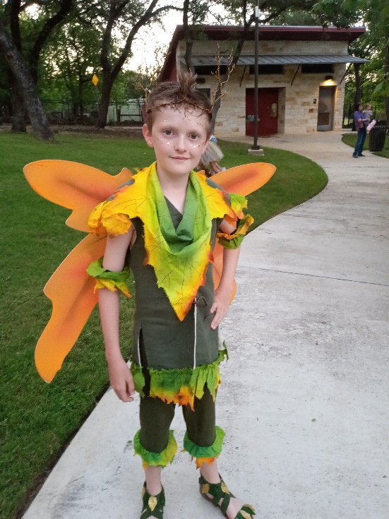
Tesher Weller played Puck in Ambleside’s Shakespeare Festival presentation of a Midsummer Night’s Dream on May 27. Ambleside closed out this school year with a wonderful presentation at the Boerne Library Amphitheater, and Tesher, as Puck, gave a fantastic performance!

Melinda, School Principal, said “We celebrate the hard work of these students in preparing for this production. We also thank the parents who supported them in learning their lines and developing their costumes.”

7
FROM THE QUILTING MINISTRY
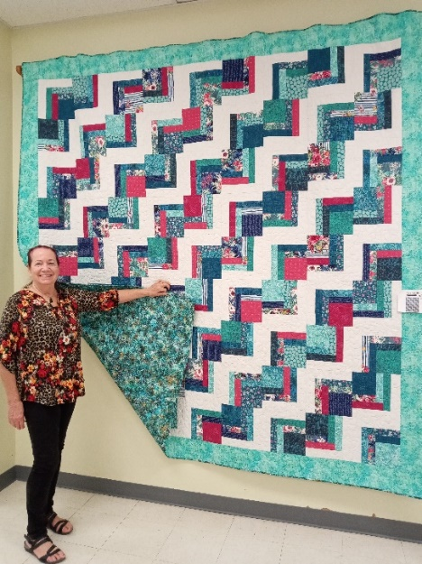
Dori Duperault is standing beside the quilt she made which will be auctioned at our fall Market Day in September or October ($5 a ticket from any of the quilters). Dori loves to quilt and shared these details about this beautiful one: She spent about 60 – 70 hours working on it in December and then a little in January and February. She did the cutting and color placement to make the design appealing to the eye, then the other Monday quilters helped with the layout of the blocks. After sewing the blocks together, Elaine Weller and Barbara Boalo helped choose the border and backing, and Rose Jeter finished it by doing the quilting. Don’t miss out on your opportunity to own this beautiful king size quilt!!

DIRECTORY UPDATE:
Barbara Boalo’s phone number is 830-328-8009. A new directory will be out in June or July – let me know if you have any changes to your information. Jackie Manning, manning2@gvtc.com. Thank you!

8

