May 2022

PIPE CREEK PIPELINE
News, notes, and updates about our church family

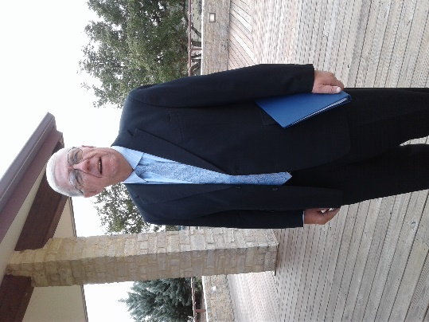
From the Pastor’s Pen…
Let’s cherish May 2022! We have so much to be thankful for in our daily lives! This year is going by very quickly, as it’s May already. Let’s make May a month of “Gratitude”. Please join me at the Bandera County Courthouse on Thursday, May 5th at 6pm for the National Day of Prayer. We will gather as a community to pray for our Nation, State, County, Veterans, First Responders, Families and Churches. We will be offering prayers of thanksgiving and asking God to continue to bless us as we serve Him. On May 8th, we celebrate Mother’s Day with gratitude for those special women who brought us into this world. On Thursday, May 12th we open our doors to the community as we host Lifeline Screening for people to participate in preventative steps to healthy living. The last weekend in May is Memorial Day weekend. On Sunday, May 29th we will gather in worship and remember those brave men and women who have paid the ultimate price for the freedoms we enjoy as a nation. God be with you and your family always! Duane Manning

8589 Highway 16 South, P.O. Box 63377, Pipe Creek TX 78063 830-510-6650
Sunday School 9:30 am Worship 10:30 am

MAY SCRIPTURE READINGS
May 1– Psalm 30; John 21: 1 - 19

May 8 – Psalm 23; John 10: 22 - 30

May 15 – Acts 11: 1 - 18; John 13: 31 - 35

May 22 – Psalm 67; John 5: 1 – 9

May 29 – Psalm 97; John 17: 20 - 26

Theme for the Month: God loves us and is always with us!

May is the “month of Love”! Each Sunday gives us an understanding of how much God loves us! We see how much Jesus loved His Father. On May 8th, we also celebrate our love for the special women God chose to be our Mom! Thursday, May 26th is the Day of Ascension, the day that Jesus ascends to Heaven to be seated with His Father. May 29th is Memorial Day in our great nation when we remember those brave men and women who gave their lives in defense of our nation so we can live as “free people” as people of God. Let us worship and love God this month! Peace & Blessings. Duane Manning

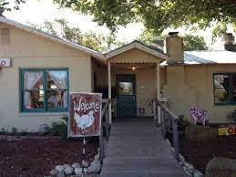
LUNCH BUNCH MEETS IN MAY
May sees the Lunch Bunch gathering at the Backyard Bistro on May 13 at noon. The Bistro, always a Pipe Creek favorite, is located at 167 Panther Ridge in Pipe Creek, on the corner of Panther Ridge and Hwy 16. Sign up at the table in Fellowship Hall to join the fun, enjoy the fellowship, and taste the good food offered at one of our finest restaurants.

For your future planning, Lunch Bunch will gather each month at a restaurant nearby. If you would like to suggest a restaurant for the group to try, contact Barbara Boalo at 830-328-8009.
2
MAY BIRTHDAYS ANNIVERSARIES
5/1 Esther Benedict 5/13 Rick & Sibby Melton
5/4 Diana Schuetze 5/17 Wayne & Donna Hannah
5/5 Gerhard Retief 5/20 Esther Benedict &
5/6 Fred Buckingham Norma Anderson
Nancy Westley 5/30 Mike & Rhonda Smith
5/13 Philip Archilla
5/26 Mike Smith
5/31 Margo Begy

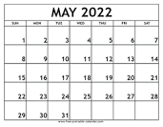
CALENDAR OF EVENTS, MAY
1 Session Meeting
5 National Day of Prayer, 6:00p, Bandera
Court House
8 Mother’s Day
12 Lifeline Screening, Fellowship Hall
30 Memorial Day

3
NOTARY SERVICES:
These folks are Notaries and are available if you need their services:
Barbara Maxwell, cell 732-600-2221
Jackie Manning, cell 830-456-7086

FROM THE QUILTING MINISTRY
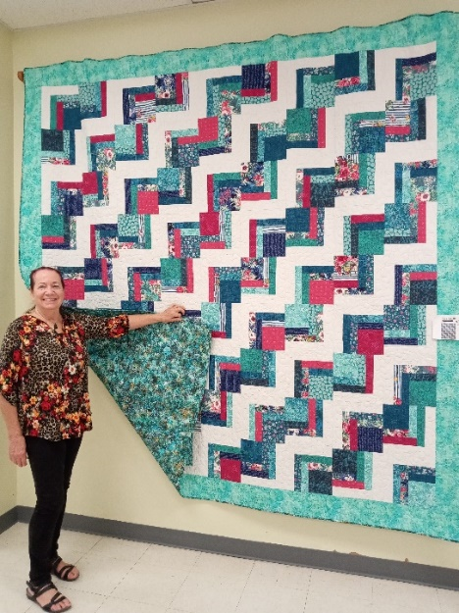
Dori Duperault is standing beside the quilt she made which will be auctioned at our fall Market Day in September or October ($5 a ticket from any of the quilters). Dori loves to quilt and shared these details about this beautiful one: She spent about 60 – 70 hours working on it in December and then a little in January and February. She did the cutting and color placement to make the design appealing to the eye, then the other Monday quilters helped with the layout of the blocks. After sewing the blocks together, Elaine Weller and Barbara Boalo helped choose the border and backing, and Rose Jeter finished it by doing the quilting. Don’t miss out on your opportunity to own this beautiful king size quilt!!

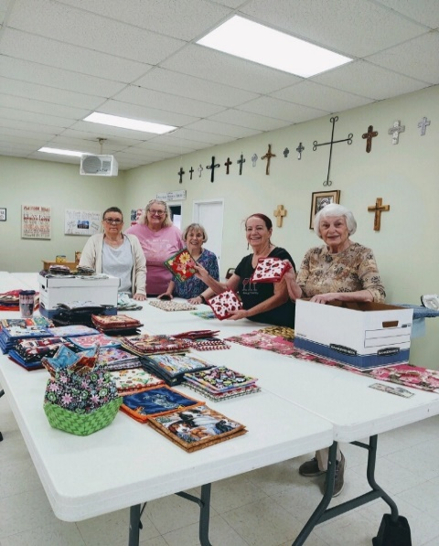

QUILTERS HAVE BEEN BUSY!!

Why wait until Market Day in September?! Newly-made potholders are available now from any quilter for $5/pair. They’re gorgeous – check ‘em out!

4

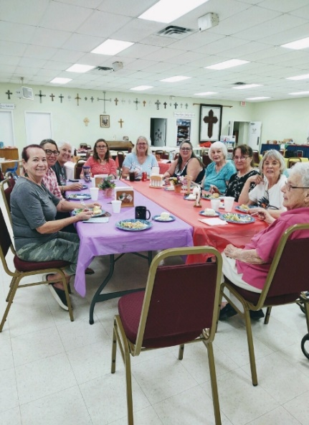
Mondays at PCPC are always fun. Here the ladies of the quilting group take a break to enjoy lunch. Smiles and conversation are always available with this group. Stop by any Monday at 9:00 and check them out

PRAYER QUILTS MAKE A DIFFERENCE IN PEOPLE’S LIVES…
From Don and Mary Pipes: Don and I thank you so much for the prayer squilt whose value to us cannot be expressed. The work, thoughts, caring, and compassion sewed into this quilt is just extraordinary!

From Sarah Nelson: Thank you so much for the beautiful prayer quilt. Your love and prayers are greatlyl appreciated. I will treasure this quilt for years to come.

From Joy: Thank you so mjuch for the handmade quilt you made for me during my recovery. I appreciate it very much.

From Willie and Regine Colbut: A special thank you to the individuals responsible formaking the beautiful, meaningful and heartwarming prayer quilt. We really appreciate the care and all the prayers as we continue in our battle with esophogus cancer at MD Anderson. Being so far away from home, our cousins Don and Terri Haga knew we needed the prayers and help from others. It is comforting to know there are so many wonderful people in the world who care.

From Kathy: Thank you for the beautiful blanket. I appreciate all the love and warmth felt with the blanket. Your thoughts and prayers daily gave me hope!
5
From Jean: Thank you for the prayer quilt. It’s beautiful. With many prayers Kathy and I are recovering.

2022 EASTER EGG HUNT WAS ENJOYED BY THE KIDDOS!

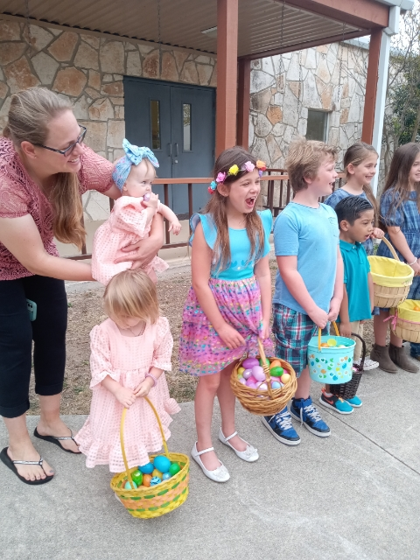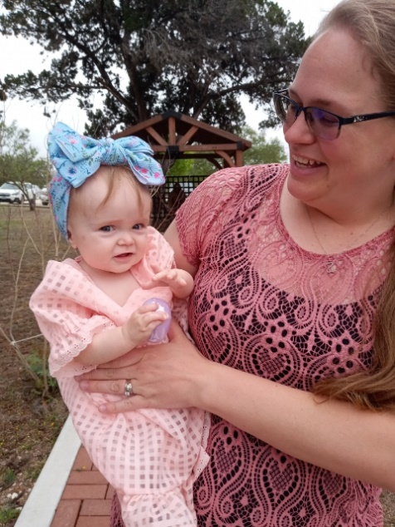

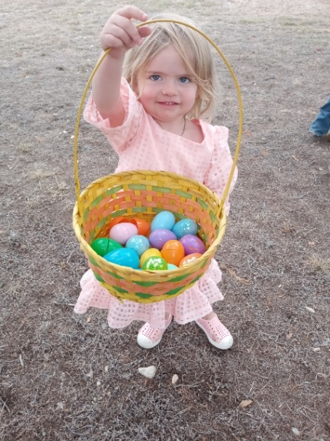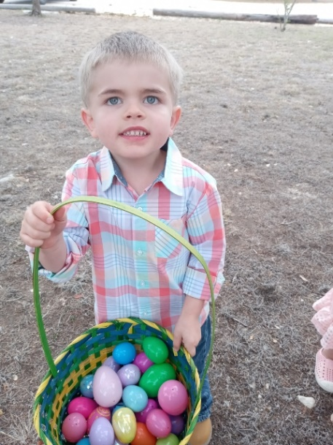

6
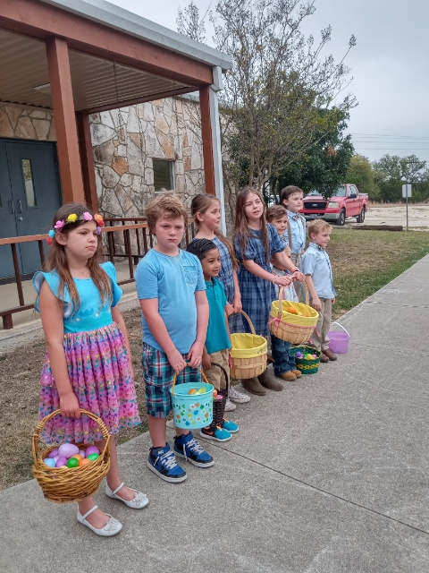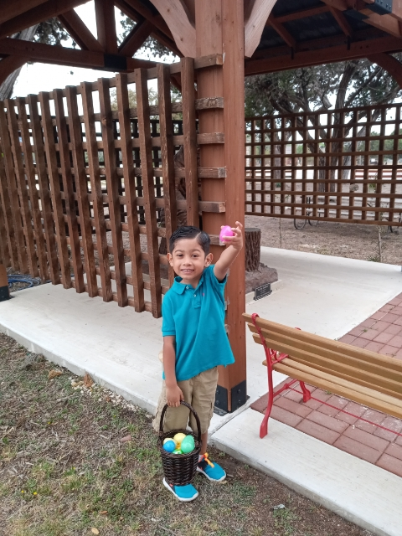

DIRECTORY UPDATE:
Doublecheck your phone number for Vernon Lamb
325-655-8903

7

