December 2022

PIPE CREEK PIPELINE
News, notes, and updates about our church family
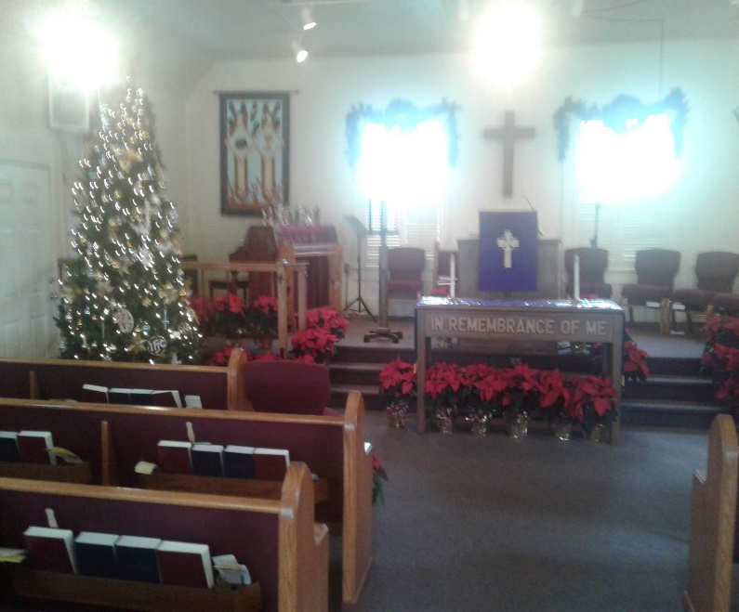
From the Pastor’s Pen…
December is a month of many different activities and emotions leading up the Christmas. We gather for worship each week while we wait for the birth of our Savior. While we wait, there are many activities to enjoy and remind us of the beauty and magic of this season. On Sunday, December 11 there will be a Community Christmas Concert at 3:00pm at the Lakehills United Methodist Church. Many of our talented choir members are singing, and you will want to celebrate this season through music. We will have a special service of remembrance called Longest Night Service on December 21 at 6:30pm. This is a special service for those in our community who are grieving the loss of a loved one. On this day of most darkness, we will gather in worship to remember God is with us always, even the darkest days. Little Rock Café will continue on December 7 and 21. We will gather for our traditional Candlelight service on Christmas Eve to hear the account of the birth of the Baby Jesus, the Messiah, Wonderful Counselor, Mighty God, Everlasting Father, and Prince of Peace. May you be filled with the wonder of this season and experience the Love of God through the birth of our Lord and Savior. I wish you and your family a very Merry Christmas! God be with you always! Duane Manning

8589 Highway 16 South, P.O. Box 63377, Pipe Creek TX 78063 830-510-6650
Sunday School 9:30 am Worship 10:30 am
DECEMBER SCRIPTURE READINGS
December 4 – Psalm 72: 1 – 7, 18 – 19; Romans 15: 4 - 13

December 11 – Psalm 146: 5 – 10, James 5: 7 - 10

December 18 - Psalm 80: 1 - 7; 17 – 19; Matthew 1: 18 - 25

December 24 – Isaiah 9: 2 - 7; Luke 2: 1 – 20

December 25 – Psalm 97; Hebrews 1: 1 - 12

Theme for the Month: Preparing for the birth of Our Savior
December 5th is the second Sunday of Advent. The theme for the second Sunday is Peace. Paul’s letter to the Romans encourages us to live in harmony with each other, Jews and Gentiles. The third Sunday of Advent, we read from James to be patient and strengthen our hearts as we await the Baby Jesus. On December 18, the children will lead us in worship with their Christmas Pageant which allows us to see and experience the birth of Jesus (Emmanuel). We will have our Candlelight service on Christmas Eve and then on Christmas morning we will gather for an informal service, reading the Christmas story and singing our favorite carols. Let us worship God together this month! Peace & Blessings.

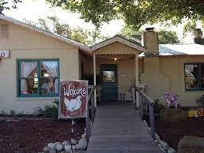
LUNCH BUNCH MEETS IN DECEMBER
December sees the Lunch Bunch heading to the Backyard Bistro in Pipe Creek on December 9, where we always enjoy great food accompanied by great friends and wonderful fellowship. Sign up at the table in Fellowship Hall to join the fun, enjoy the fellowship, and taste the good food offered at one of our finest restaurants. See you at noon at The Bistro
For your future planning, Lunch Bunch gathers each month at a nearby restaurant. If you would like to suggest a restaurant for the group, contact Barbara Boalo at 830-328-8009.
2
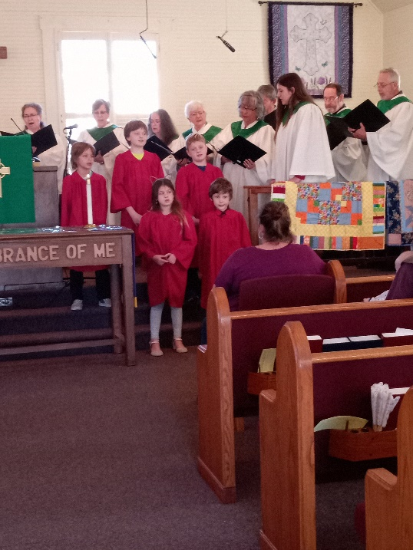
WORSHIP GOD WITH SOUNDS
OF JOY!!
On Sunday, November 20, PCPC was blessed to hear both choirs sing and lead us in worship.

On December 18, the children will lead us in worship with their Christmas Pageant which allows us to see and experience the birth of Jesus (Emmanuel) (extract from the pastor’s Theme of the Month article on page 2).

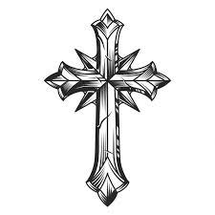

Siobhan Smith says “thank you”
I am sorry this took me so long, but it was the last thing I needed to do for my grandmother’s funeral (Sharon Jeanne Hopper’s memorial service was held at PCPC on October 29) and I’ve put it off because I wasn’t ready. However, I just wanted to thank everyone from the bottom of my heart for the gracious love and support you gave to not only myself, but my extended family as well. I am grateful to the congregation for your donations in food and allowing me to come home to grieve the passing and celebrate the life of my grandmother, Sharon Rogers. I also wanted to say thank you so much for the prayer quilt. You’ll never know how much that truly touched me. I’ve been struggling with my faith and the whole experience from reaching out, to planning, executing the funeral, and then receiving the blanket was so heartfelt. The blanket also kept me warm and safe on my way home in the airport. Again, thank you all so very much. It was great to see those of you that I did and to meet new faces from the church I have not met. I hope to come back soon (I live very far away in Ohio). But I just wanted everyone to know what an amazing team of people came together to support me during an incredibly difficult time. Thank you so much and God bless!!

3
DECEMBER BIRTHDAYS No anniversaries in December
12/1 Bill Bowie
Donna Hannah
12/3 John Schuetze
12/5 Kitty Firneisen
12/6 Irene Smith
12/13 Tahmar Rasmussen
Sibby Melton
12/16 Yvonne McPherson
12/23 Michael Kelley
Lorna Wilson
12/31 Barbara Savary

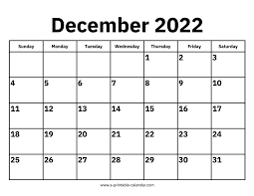
CALENDAR OF EVENTS, DECEMBER
Dec 4 Jesus’ Birthday Party, 9:30a
Dec 7 Little Rock Café, 5:30p
Dec 9 Lunch Bunch, noon, The Bistro
Dec 11 Community Christmas Concert, 3:00p
Lakehills United Methodist Church
Dec 12 Quilters’ Christmas Party, 10:00a
Dec 21 Little Rock Café, 5:30p
Dec 21 Longest Night Svc, 6:30p

4
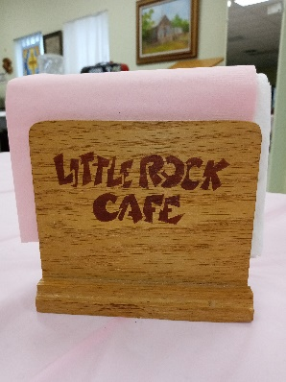
THE DOOR IS OPEN AT THE LITTLE ROCK CAFÉ…
The Little Rock Café continues to serve up excellent food to our congregation and community friends -- dinner is served at 5:30pm on the first and third Wednesdays of each month. Although usually followed by Bible study with Philip Archilla, there’s no Wednesday night Bible study until Philip announces the next schedule.
We’ve reinstituted the fun of pulling the name of an attendee to win that person a free dinner at the next café. Maybe your name will be drawn for a free dinner at the next café!!
Dori Duperault and Barbara Boalo are serving beef cannelloni on December 7 and Duane and Jackie Manning plan on serving ham on December 21. Enjoy a night out without having to cook. See you at the café!

NOTARY SERVICES:
These folks are Notaries and are available if you need their services:
Barbara Maxwell, cell 732-600-2221 Jackie Manning, cell 830-456-7086

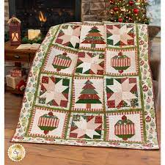
FROM THE QUILTING MINISTRY
The quilters are looking forward to their annual Christmas party, this year on December 12 at 10:00a. There are lots of laughter, delicious food, games, prizes, and friends enjoying the holidays.

Wrap and bring a present (value $10-$20) for the gift exchange, maybe even dress for the holidays, and plan on being with your friends from 10:00a – 1:00p. Questions? Contact Dori Duperault or Barbara Boalo.

“When you dream alone, it is only a dream. But when we dream with others,
it’s no longer a dream but the beginning of reality.”
5
PCPC friends and family gathered to decorate the sanctuary on Tuesday afternoon, November 21. We’re ready for Advent.

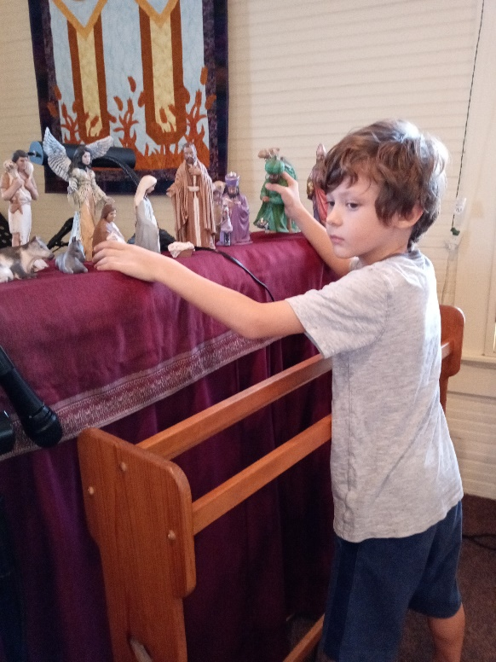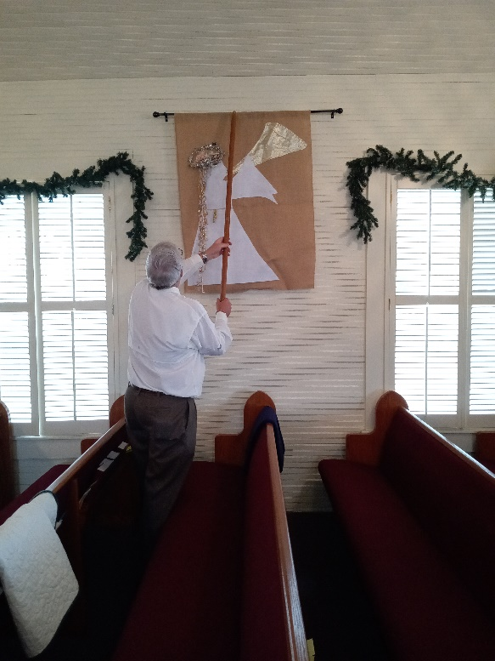

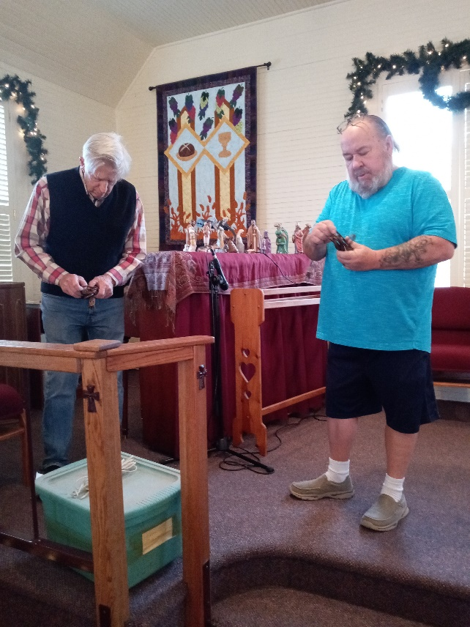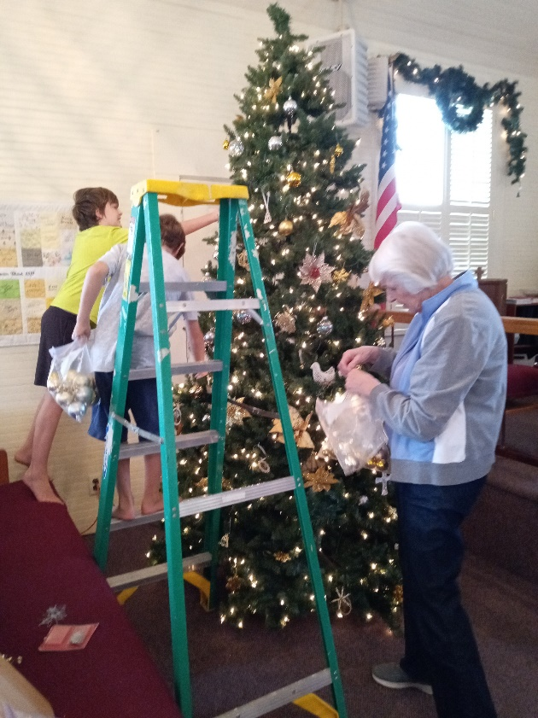
6

