January 2023
PIPE CREEK PIPELINE
News, notes, and updates about our church family
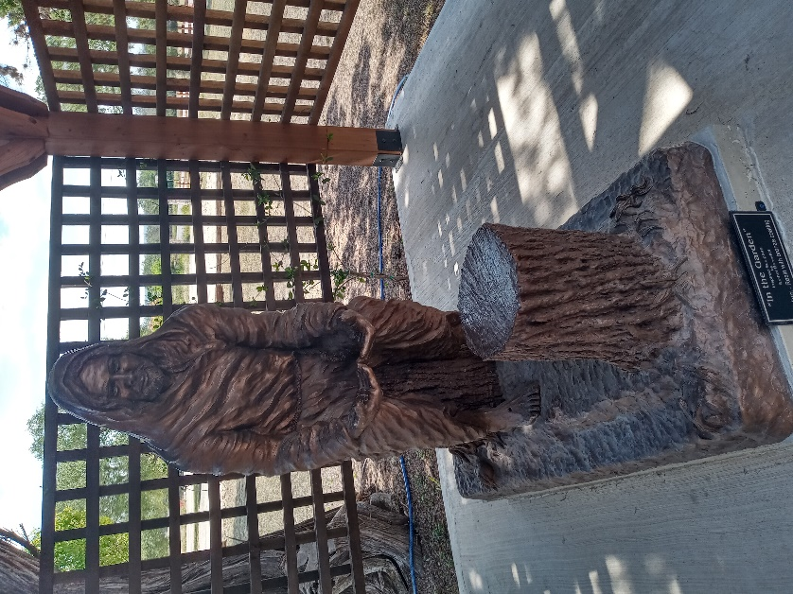
From the Pastor’s Pen…
Happy New Year! For those of us hoping and praying 2022 would end, we begin a new live filled with Hope! The new year offers us an opportunity to “do a reset!” We can do a “reset” in our faith journey also. Let’s gather for worship as a church family and journey with Jesus, our Lord and Savior. Please read about the scripture passages we will read in January. We read about the beginning of Jesus life on earth as He fulfills God’s plan. He is fully human and fully God, teaching and leading us as God’s chosen children. Our annual congregational meeting will be held after worship on January 15th. We will receive reports on all that happened in 2022 and review the budget for 2023. We will receive a report from the nominating committee and elect the elders to serve on Session. The newly elected elders will be ordained and/or installed during worship on January 22. I’m excited about the promise of new beginnings in a New Year. Please join me as we seek to glorify God in all we do. May God be with you and your family always!
Duane Manning

8589 Highway 16 South, P.O. Box 63377, Pipe Creek TX 78063 830-510-6650
Sunday School 9:30 am Worship 10:30 am
January Scripture Passages
January 1 – Psalm 63: 7 - 9; Matthew 2: 13 - 23

January 8 – Isaiah 42: 1 - 9; Matthew 3: 13 - 17

January 15 – Psalm 40: 1 - 11; John 1: 29 - 42

January 22 – Psalm 27: 1, 4 - 9; Matthew 4: 12 - 23

January 29 – Psalm 15; Matthew 5: 1 - 12

Theme for the Month: Jesus’ Ministry Begins
Happy 2023! We have five Sundays in January to worship God as Jesus begins his ministry on earth. As we gather each Sunday, we will experience all of the ways that Jesus’ ministry directly applies to us. We will also see and hear how Jesus came to fulfill God’s plan for the world. Let us worship God together this month! Peace & Blessings.
Duane Manning

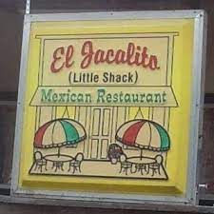
LUNCH BUNCH STARTS THE NEW YEAR
AT EL JACALITO
January kicks off the new year and sees the Lunch Bunch heading to El Jacalito in Bandera on January 13. Come and join us at 1207 Cedar St in Bandera at noon, where we will enjoy delicious food and fantastic fellowship. Sign up at the table in Fellowship Hall to join the fun at one of Bandera’s best restaurants.

For your future planning, Lunch Bunch gathers each month at a nearby restaurant. If you would like to suggest a restaurant for the group, contact Barbara Boalo at 830-328-8009.
2
JANUARY BIRTHDAYS ANNIVERSARIES
1/14 Egan Weller 1/1 Kevin and Lisa Johnson
1/17 Stephen Weller
1/18 Susan Barden
1/23 Deb MacDonald
Don Haga
1/24 Bill Schultz
1/28 Mary Lou Westley
1/30 Rick Melton
Fred Hildebrand
1/31 Vernon Lamb

CALENDAR OF EVENTS, JANUARY
Jan 3 Take down Christmas decorations
Jan 4 Little Rock Café, 5:30p
Jan 6 Kitty Firneisen Memorial Svc, 11:30a,
Family cemetery, followed by lunch at Grey Forest Civic Center
Jan 13 Lunch Bunch, El Jacalito, noon,
Bandera
Jan 15 Annual Congregational Meeting,
following worship
Jan 18 Little Rock Café, 5:30p
Jan 22 Install new elders, worship service
3
CHRISTMAS WAS A TRULY SPECIAL TIME IN THE LIFE OF PCPC…

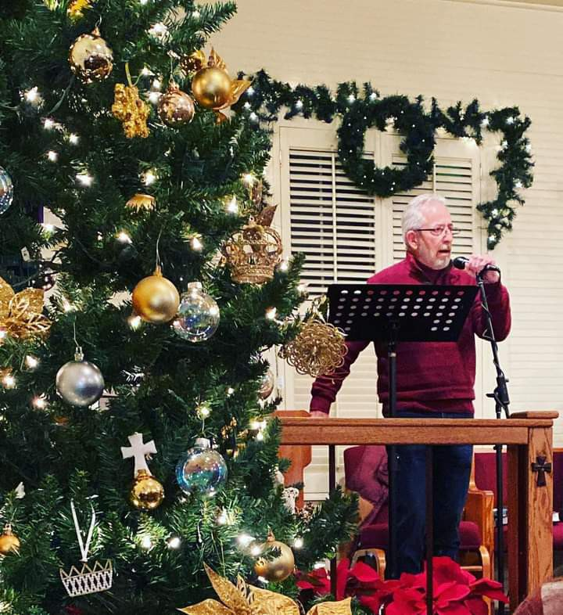

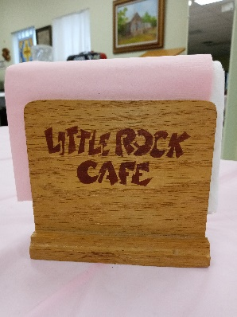
THE DOOR IS OPEN AT THE LITTLE ROCK
CAFÉ…
The Little Rock Café continues to serve up excellent food to our congregation and community friends -- dinner is served at 5:30pm on the first and third Wednesdays of each month. Although usually followed by Bible study with Philip Archilla, there’s no Wednesday night Bible study until Philip announces the next schedule.
We’ve reinstituted the fun of pulling the name of an attendee to win that person a free dinner at the next café. Maybe your name will be drawn for a free dinner at the next café!! We have dinners planned for January 4 and January 18. Enjoy a night out without having to cook. See you at the café!

NOTARY SERVICES:
These folks are Notaries and are available if you need their services:
Barbara Maxwell, cell 732-600-2221 Jackie Manning, cell 830-456-7086

4
FROM THE QUILTING MINISTRY
The quilters certainly know how to throw a good party! On December 12, they met to enjoy their fellowship, good food, games and prizes, and a gift exchange.

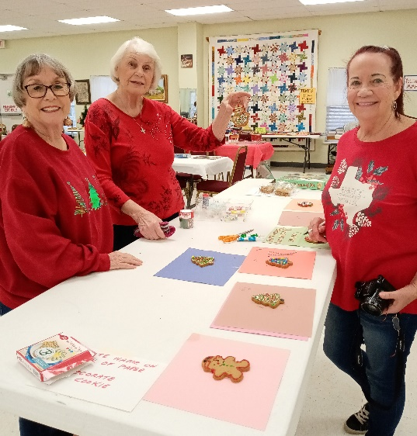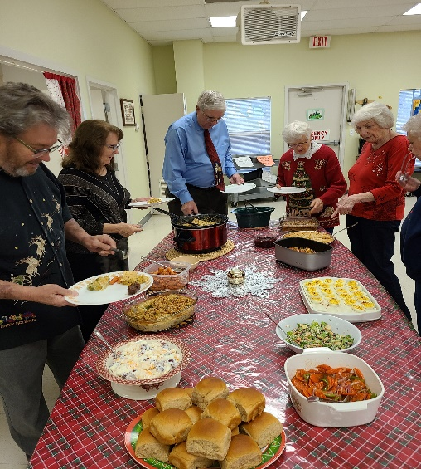

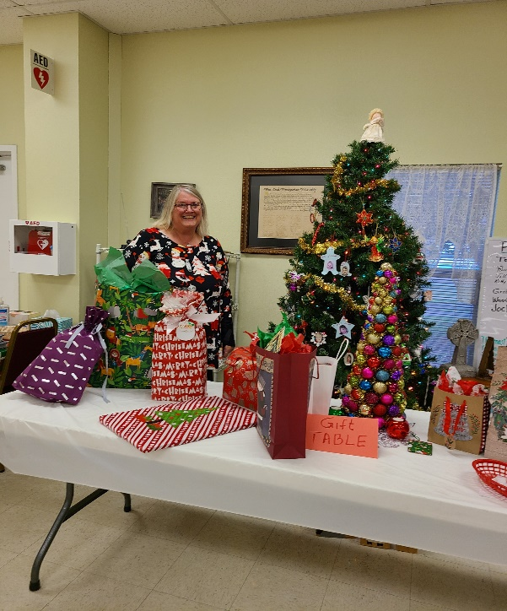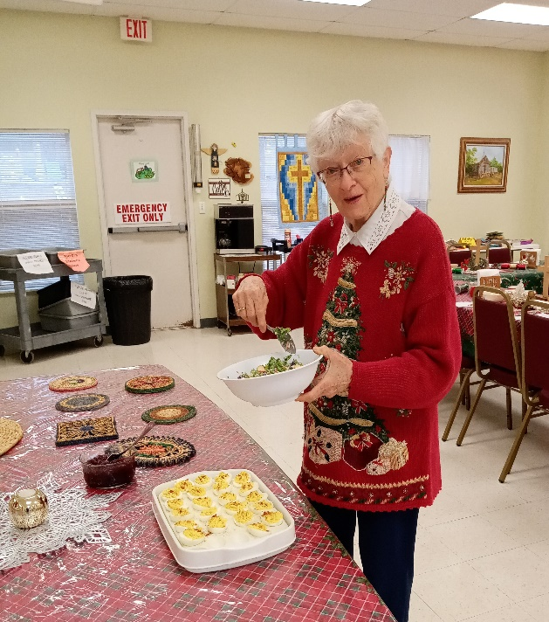
5
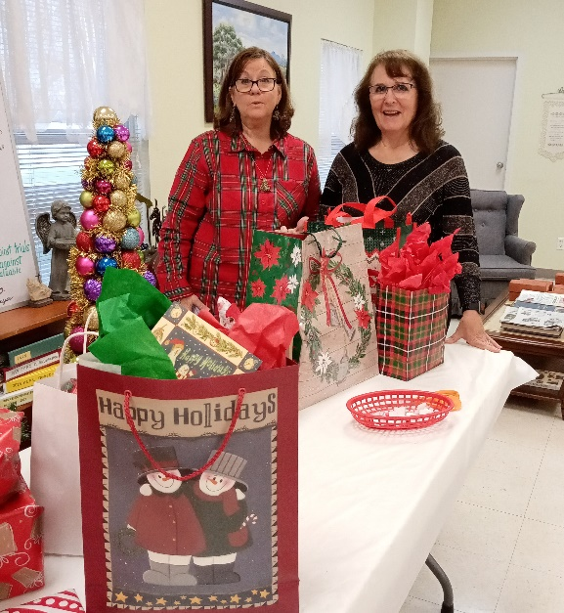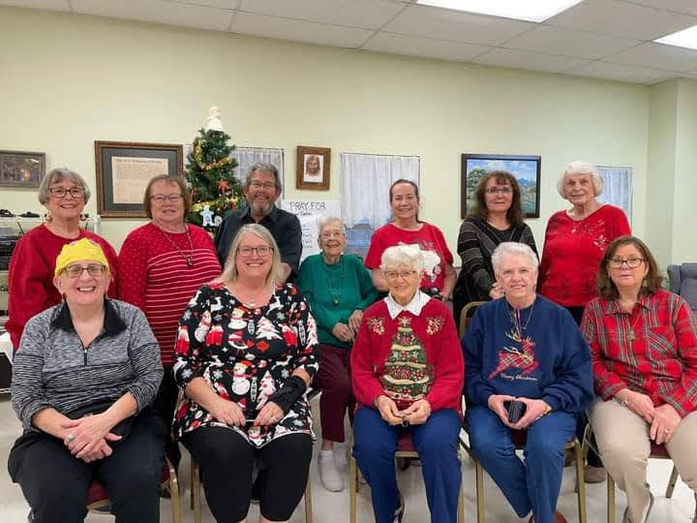

6

