February 2023
PIPE CREEK PIPELINE
News, notes, and updates about our church family

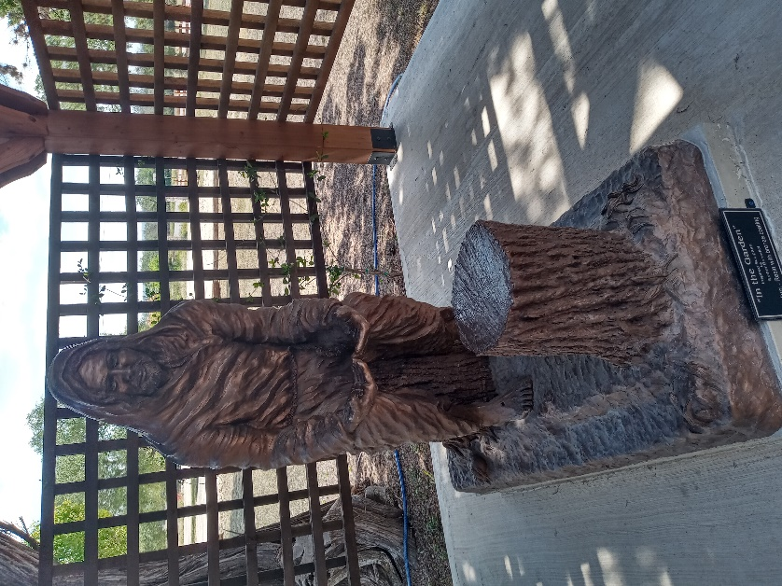
From the Pastor’s Pen…
February is a short month but is filled with many exciting opportunities to share in the glory of God. The first Sunday in February we will celebrate the Sacrament of Holy Communion. This is also a Sunday to remember our Chaplains who serve in the military and in our communities around the world. Rev. Chuck Cornelisse is a retired Air Force Chaplain and he will lead us in worship on this special day. We will have many opportunities to gather as the body of Christ for worship, bible study, and fellowship throughout the month. Wednesday, February 22 is Ash Wednesday, the beginning of Lent. We will gather for a light supper at 5:30pm followed by our traditional Ash Wednesday service at 6:30pm. Let’s continue to gather as a church family as we appreciate all the ways God Loves us! May we share the Love of God with each other, our friends and neighbors. May God be with you and your family always! Duane Manning

8589 Highway 16 South, P.O. Box 63377, Pipe Creek TX 78063 830-510-6650
Sunday School 9:30 am Worship 10:30 am
February Scripture Passages
February 5 -- Exodus 32: 7 - 14; Luke 15: 1 - 2

February 12 -- Psalm 119: 1 - 8; Matthew 5: 21 - 37

February 19 -- Transfiguration of the Lord – Psalm 99; Matthew 17: 1 - 9

February 26 -- Psalm 32; Matthew 4: 1 – 11

Theme for the Month: Godly Living
February may be a short month as far as number of days but there are lots of important events in our journey with Jesus. On February 5th, Jesus tells the people, “you are the salt of the earth.” He teaches them to “let your lights shine before others.” Jesus said to let all we do give glory to God! February 14th (Happy Valentine’s Day) is on Tuesday. Let’s spend the day showing our love for someone that reflects God’s love for us! On this day of “Love”, let’s remember Jesus’ answer of the most important commandments, “Love God and Love Neighbor.” Sunday, February 19th is the Transfiguration of the Lord Sunday. Jesus is revealed to Peter, James and John by God who tells them “Jesus is my Son, the Beloved, listen to him.” Let us worship God together this month!
Peace & Blessings. Duane Manning

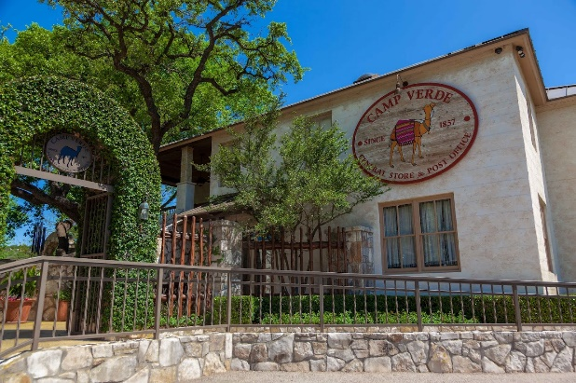
LUNCH BUNCH HITS THE ROAD IN FEBRUARY
February requires us to pull up our GPS and find Camp Verde, Texas. Lunch Bunch is heading to Camp Verde General Store and Restaurant in Camp Verde, outside of Center Point, Texas, on February 10. Come and join us at 285 Camp Verde Road E at noon, where we will enjoy outstanding food, beautiful vistas, and fun shopping. Sign up at the table in Fellowship Hall to join the fun at one of the Hill Country’s beloved restaurants.

For your future planning, Lunch Bunch gathers each month at a nearby restaurant. If you would like to suggest a restaurant for the group, contact Barbara Boalo at 830-328-8009.
2
FEBRUARY BIRTHDAYS ANNIVERSARIES
2/11 Norma Anderson 2/10 Harry and Barbara Maxwell
2/17 Mary MacPherson 2/11 Tom and Pam Morrow
Joshua Retief
2/20 Darlene Hildebrand
2/23 Cathy Witt

CALENDAR OF EVENTS, FEBRUARY
Feb 1 Little Rock Café, 5:30p, followed by
Bible Study with Philip A
Feb 5 Session Meeting following worship
Feb 8 Bible Study with Philip A at 6:30p
Feb 10 Lunch Bunch, Camp Verde, noon
Feb 15 Little Rock Café, 5:30p, followed by
Bible Study with Philip A
Feb 22 Ash Wednesday service, 6:30p

3
Dear PCPC Family,

Many of you have probably heard by now that I’ve decided to step down from my music roles at PCPC, beginning this coming June.

I have known for a number of years that my involvement in the music program at PCPC was not meant to continue indefinitely. Over the past year, as our family has been adjusting to the major change in the boys’ schooling, it has given Stephen and me the opportunity to think deeply about what is best for our family in this season. I feel peace about the decision to step back from the church position.

I have been blessed to serve PCPC as a musician for almost 17 years. It has brought an incredible amount of creative outlet and meaning to my life, so this decision has been difficult to make. But I also realize that as my boys have been growing, I have not been able to be available to them as “Mom” at church. So while I feel sadness at the closing of this beautiful chapter, I look forward to the opening of a new one.

As PCPC looks toward this big change, I am praying that the right person—or possibly people—will feel the call to serve. The church will primarily looking to fill the piano accompanist position. (Our already-small choir has several members who may not be able to commit to continuing in the fall for various reasons.) It may well be that the best scenario going forward will be several people sharing the position and playing on a rotating schedule of some kind. It has always been hard for churches in Bandera County to find full-time accompanists—at least one other church in the area is also looking for someone right now. So if you know of any leads or possibilities, please let me or someone on session know. And, of course, if you are a musician yourself and you feel the call to help meet this need, you will be so appreciated!

I have been deeply blessed to be a musician and music leader at PCPC for all these years. You have been much, much more than just a church or a job—you have been a family. I will always thank God for you!
With love and gratitude, Ashley
4

THE CHILDREN’S PAGEANT WAS ABSOLUTELY BEAUTIFUL!!
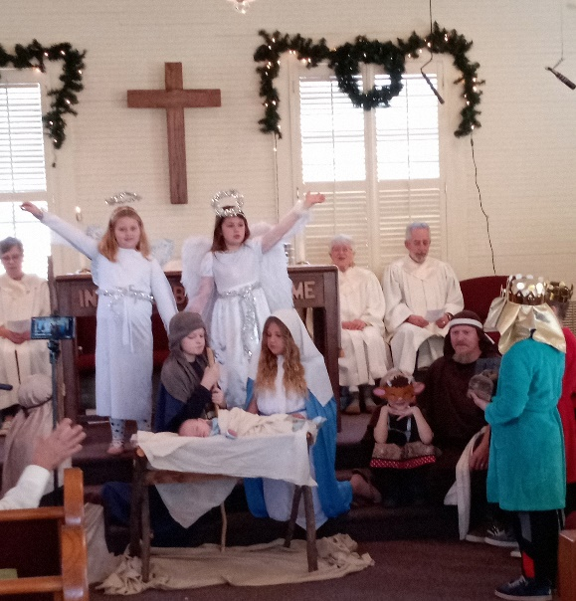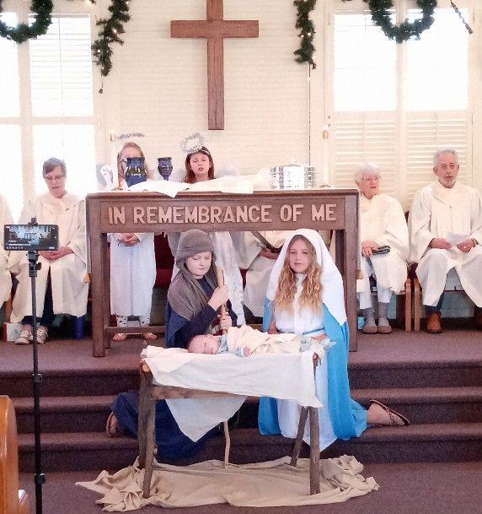

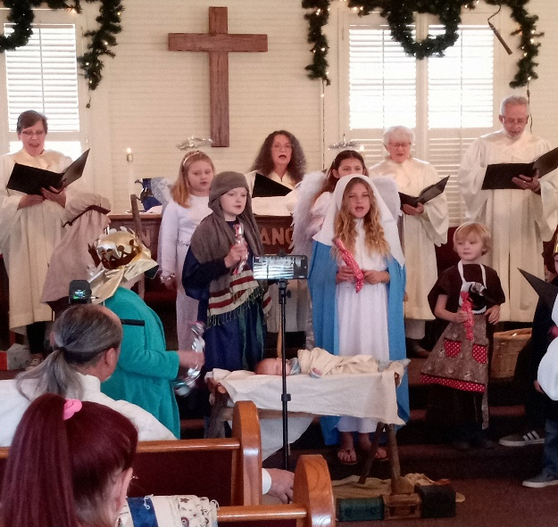

THANK YOU, PCPC
Dear PCPC, Thank you for the delicious meal prepared for our family to honor our dad at his Celebration of Life. The meatloaf with “Ralph’s sauce” and all the fixings were very heartwarming – he would have loved it. We appreciate all of the homemade goodies for dessert.
Thank you, PCPC, for making the meal and service so special.
Thank you from the Woodhall, Johnson, Henderlong, Stuart, Kraemer land Bents families!
5
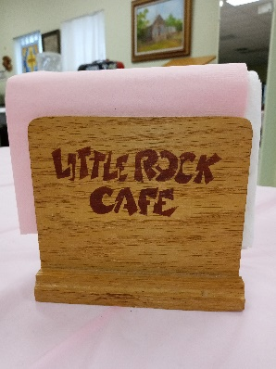
THE DOOR IS OPEN AT THE
LITTLE ROCK CAFÉ…
The Little Rock Café continues to serve up excellent food to our congregation and community friends -- dinner is served at 5:30pm on the first and third Wednesdays of each month.
We’ve reinstituted the fun of pulling the name of an attendee to win that person a free dinner at the next café. Maybe your name will be drawn for a free dinner at the next café!! We have dinners planned for February 1st and 15th . Enjoy a night out without having to cook. See you at the café!

LUNCH BUNCH IS ALL SMILES…
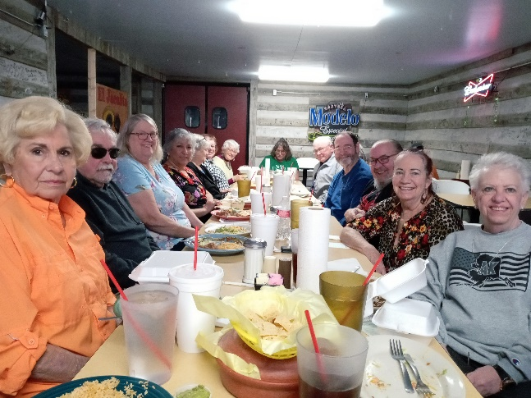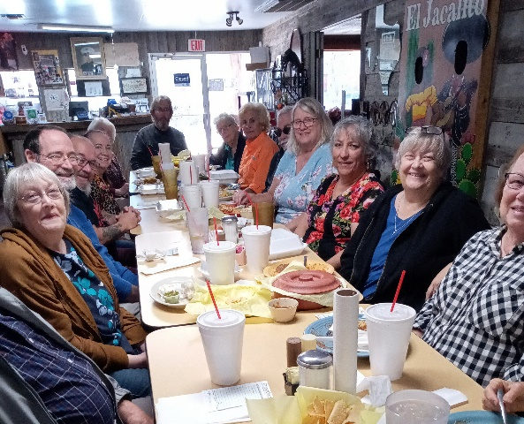
We had 17 people attend the Lunch Bunch at El Jacalito in Bandera in January. What a great looking bunch of friends!!

BIBLE STUDY IS OFFERED TWICE A WEEK TO FIT YOUR BUSY SCHEDULE: Join Pastor Duane on Tuesday’s at 11:00a in Fellowship Hall. This is usually a preview and discussion for the following Sunday’s scriptures and message. Bring your own lunch to enjoy at noon following study. If Tuesday doesn’t work in your schedule, then join Philip A at his Bible study on Wednesday evenings – it meets at 7:00p on the Café nights and meets at 6:30p on the other Wednesday nights also in Fellowship Hall.
6
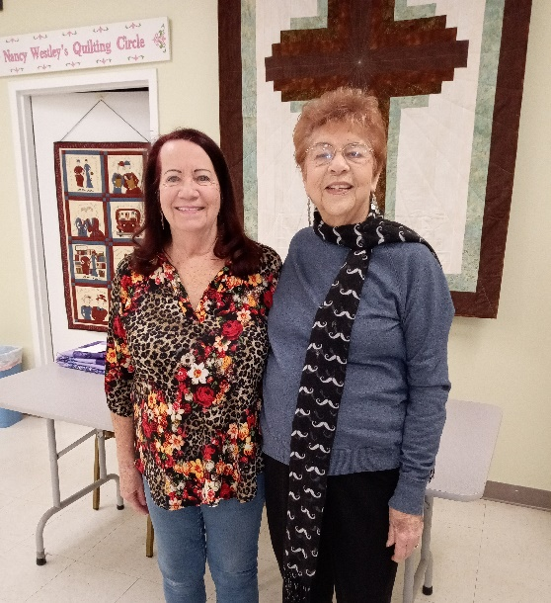
At the January 15 Congregational Meeting, the congregation voted to bring on Session for three years Dori Duperault and Nan Moody. Nan has served previously as an elder, this is Dori’s first opportunity to serve. Duane thanked outgoing elders, Rick Melton and Darlene Hildebrand, for their service, dedication, and enthusiasm as they rotate off Session. Ministry assignments will be made at the February 5 meeting.

FROM THE QUILTING MINISTRY…
Dear Pipe Creek Presbyterian ladies, Thank you so much for the prayer blanket. It’s so beautiful and fits well with Shelby with the red, white and blue. You can feel the love and prayers when he wraps up in it! God bless ya’ll! The Westfall Family

HOUSEKEEPING INFO…
Michael Kelley has a new phone number. Please update your phones and church directory: 830-688-1342

A new email for Don and Terri Haga. Please update your phones and church directory:
tdhaga17@gmail.com

“What good is the warmth of summer, without the cold
of winter to give it sweetness.” John Steinbeck

7

