 **2023**

PIPE CREEK PIPELINE

News, notes, and updates about our church family



From the Pastor’s Pen…

Every Sunday is special! June 2023 is a great example of that thought. The first Sunday in June is Trinity Sunday. We will gather for worship in the name of the Father, Son, and Holy Spirit. The theme of the second Sunday tells us how important our faith is to our wellness. The third Sunday is Father’s Day, and we will remember those special men that brought us into this world! On the last Sunday in June, we reflect on the importance of giving our lives to Christ. There are many opportunities for worship and fellowship that will make your summer enjoyable. God be with you and your family always! Pastor Duane Manning

8589 Highway 16 South, P.O. Box 63377, Pipe Creek TX 78063 830-510-6650

Sunday School 9:30 am Worship 10:30 am

**JUNE SCRIPTURE PASSAGES**

June 4 – Trinity Sunday – Psalm 8; Matthew 28:16 - 20

June 12 – Psalm 50:7 - 15; Matthew 9:9 – 13, 18 - 26

June 18 – Father’s Day – Psalm 100; Matthew 9:35 – 10: 23

June 26 – Psalm 69: 7 - 15; Matthew 10:24 - 39

Theme for the Month: Give Your Life to Christ

June begins with the Trinity Sunday when we worship God the Father, Son, and Holy Spirit. The remaining three Sundays give us stories of how faith heals us; the Holy Spirit will speak through us; and what it means to give our life to Christ. On June 18th, we celebrate Father’s Day and listen as Jesus sends out the 12 apostles. He tells them that the harvest is plentiful but the laborers are few. The last Sunday in June is a day to think about giving our life to Christ. As we begin our summer, let’s remember we’re led by the Holy Spirit as we proclaim all of the great things God has done for us. Let’s gather for worship and fellowship as we become the Church God has planned for us to be!



**LUNCH BUNCH DINES AT A FAVORITE IN BANDERA IN JUNE**

Bandera has several great restaurants and the Lunch Bunch enjoys another one in June. We return to China Bowl (1203 Pecan Street, Bandera) on June 16 at noon. Sign up at the table in Fellowship Hall to join the fun at one of Bandera’s great restaurants.

For your future planning, Lunch Bunch gathers each month at a nearby restaurant. If you would like to suggest a restaurant for the group, contact Barbara Boalo at 830-328-8009.

2

**JUNE BIRTHDAYS ANNIVERSARIES**

6/1 Jena Kraemer 6/6 Delmar & Mary Potter

6/2 Norine Chamberlain 6/13 Thomas & Jena Kraemer

6/4 Elaine Weller

6/5 Robert MacDonald

6/6 Jim Chenault

6/9 Dori Duperault

6/11 Tom Cortes

6/16 Warner Hord

6/21 Thomas Kraemer

6/26 Gail Hord

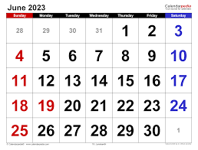**CALENDAR OF EVENTS, JUNE**

Jun 4 Session Meeting

Jun 10 Church work day, 9:00a

Jun 16 Lunch Bunch,

China Bowl, Bandera, noon

Jun 18 Father’s Day

3

**THE BIBLE IN 50 WORDS**

God made. Adam bit. Noah arked. Abraham split. Jacob fooled. Joseph ruled. Bush talked. Moses balked. Pharaoh plagued, people walked, sea divided, tablets guided, promised landed. Saul freaked. David peeked. Prophets warned. Jesus born. God walked. Love talked. Anger crucified. Hope died. Love rose. Spirit flamed. Work spread. Faith lived. --Joseph Ruffo

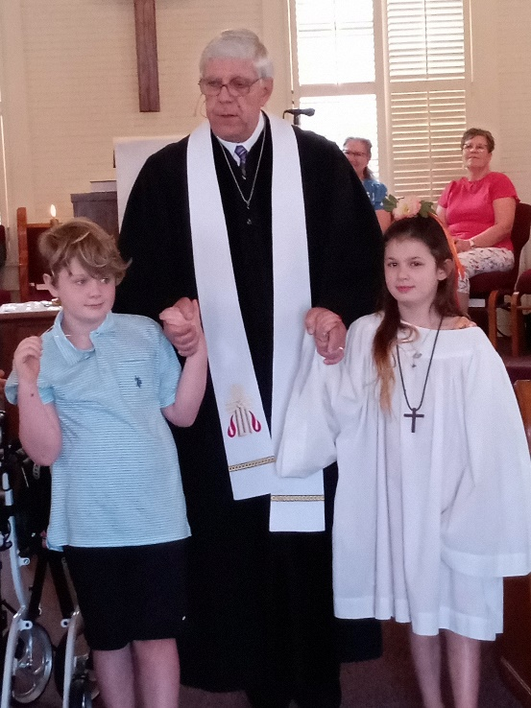In addition to celebrating Mother’s Day on May 14, PCPC celebrated the Sacrament of Baptism of Mandalyn and Hendrix Rasmussen. The congregation has watched these two young people grow and mature as Christians and wish them special blessings as they continue in their faith journey.

4

**AN OFFERING OF THANKS FOR THE PCPC FAMLY --**

From the Strosser Family: Dear friends and family of Pipe Creek Presbyterian Church – Thank you all for the calls, cards, and food sent to our family. We have been so comforted and have felt your prayers surrounding us at this time. May God continue to bless all of you. Pam Strosser and family.

PCPC is pleased to announce the marriage of Tony Atkinson and Melin Richards in the PCPC sanctuary on May 21. The beautiful ceremony was officiated by Pastor Duane Manning and a reception and meal were held in Fellowship Hall following the ceremony. Congrats Tony and Melin and best wishes for a full and exciting future as husband and wife!

**FROM THE QUILT MINISTRY**

Thank you all so much for the beautiful prayer quilt and prayers for my husband, Jackie McLendon. It is so appreciated and God bless all of you. Sister in Christ, Glenda McLendon

5

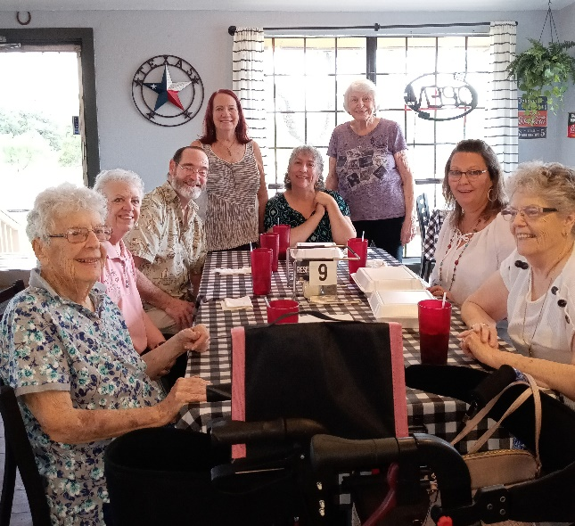The Lunch Bunch enjoyed trying a new restaurant in Bandera for the May Lunch Bunch gathering. Maggio’s Pizza was checked out and was eager to serve our group on May 19. Sorry we missed Yvonne McPherson—she’d stepped away before this picture was taken.

**TIME AND TALENT SURVEY**

Please complete the Time and Talent Survey included in this Pipeline and share your talents and abilities (things you enjoy and are good at!). This survey allows us to know which of our members would be good on which committees, who is willing to serve and in which areas, and those who have talents that can be shared. Questions? Contact Barbara Boalo at 830-328-8009.



PCPC Directory Update: Duane and Jackie Manning’s address changed. Please update it to 2005 Grand Loop, Boerne TX 78006

6

TIME AND TALENT SURVEY

God has blessed us all with talents and skills. Please share yours with us by completing our survey. Please describe any skills and talents that you have:

___________________________________________

___________________________________________

What ministries would you be interested in serving?

____ Youth ____ Worship

____ Usher ____ Choir

____ Liturgist/reader ____ Prayer quilts

____ Music Instrument ____ Fundraising

____ Meal services (Little Rock Café, memorial

dinners

____ Gardening ____ Repairs (general)

____ Repairs (Plumbing) ____ Repairs (electrical)

____ General housekeeping/cleaning

What times would work best for you? Check all that apply:

____ mornings ____ afternoons

____ evenings ____ weekdays

____ weekends ____ one-time projects

____ long-term projects

____ short-term projects

Willing to serve with/in following ministries:

____ Childrens Christian Education

____ Worship ____ Nurture

____ Stewardship/Finance

____ Outreach ____ Property

Ideas for new ministries:

______________________________________

______________________________________

______________________________________

- - - - - - - - - - - - - - - - - - - - - - - - - - - - - - - - - - - - - - - - - -

NAME: _______________________________________

Preferred phone # _______________________________

E-mail ________________________________________

Preferred method of contact:

____ email ____ phone ____ text

**Your talent is God’s gift to you. What you do with it is your gift back to God.**

Please return survey to church office or to Barbara Boalo