**2023**

PIPE CREEK PIPELINE

News, notes, and updates about our church family



From the Pastor’s Pen…

Let’s cherish May! We have so much to be thankful for in our daily lives! This year is going by very quickly, as it’s May already. Let’s make May a month of “Gratitude”. Please join me at the Bandera County Courthouse on Thursday, May 4 at 6pm for the National Day of Prayer. We will gather as a community to pray for our Nation, State, County, Veterans, First Responders, Families and Churches. We will offer prayers of thanksgiving and ask God to continue to bless us as we serve Him. On Thursday, May 11 we open our doors to the community as we host Life Line Screening for people to participate in preventative steps to healthy living. On May 14, we celebrate Mother’s Day with gratitude for those special women who brought us into this world. The last weekend in May is Memorial Day weekend. On Sunday, May 28 we will gather in worship and remember those brave men and women who have paid the ultimate price for the freedoms we enjoy as a nation. God be with you and your family always! Pastor Duane Manning

8589 Highway 16 South, P.O. Box 63377, Pipe Creek TX 78063 830-510-6650

Sunday School 9:30 am Worship 10:30 am

**MAY SCRIPTURE PASSAGES**

May 7– Psalm 119: 9 - 32; John 14: 1 - 14

May 14 – Psalm 115; John 14: 15 - 21

May 21 – Psalm 21: 1 - 7; John 17: 1 - 11

May 28 – Day of Pentecost - Acts 2: 1 - 21; John 7: 37 – 39

Theme for the Month: Jesus Prepares the Way for us

May is the “month of Love”! We know how much God loves us that He sent Jesus to save us. The first three Sundays describe Jesus’ final actions before going to His Father in Heaven. Jesus is preparing the Way for us to go with Him in God’s timing. On May 14, we also celebrate our love for the special women God chose to be our Mom! We will also celebrate the Sacrament of Holy Baptism as Mandy and Hendrix are Baptized. Thursday, May 18th is the Day of Ascension, the day that Jesus ascends to Heaven to be seated with His Father. May 28 is Memorial Day in our great nation when we remember those brave men and women who gave their lives in defense of our nation so we can live as “free people” as people of God. Let us worship and love God this month! Peace & Blessings. Duane Manning

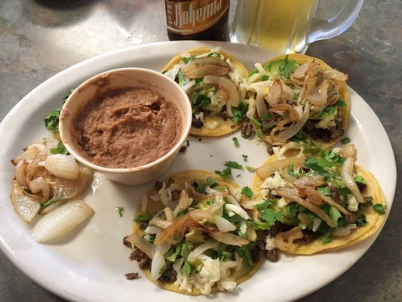 **LUNCH BUNCH REMAINS LOCAL IN BANDERA IN MAY**

Bandera has several great restaurants and the Lunch Bunch enjoys another one in May. This time is Maggio’s Italian Restaurant on Hwy 16S. Join us at noon on May 19 when we will enjoy outstanding food and friends! Sign up at the table in Fellowship Hall to join the fun and a taste of Italy at one of Bandera’s most interesting restaurants.

For your future planning, Lunch Bunch gathers each month at a nearby restaurant. If you would like to suggest a restaurant for the group, contact Barbara Boalo at 830-328-8009.

2

**MAY BIRTHDAYS ANNIVERSARIES**

5/1 Esther Benedict 5/13 Rick & Sibby Melton

5/4 Diana Schuetze 5/17 Wayne & Donna Hannah

5/6 Nancy Westley 5/20 Esther Benedict &

5/13 Philip Archilla Norma Anderson

5/26 Mike Smith 5/30 Mike & Rhonda Smith

**CALENDAR OF EVENTS, MAY**

May 2 Bible Study with Kirk

May 11 Life Line Screening, 8:00a

May 14 Mother’s Day and taco Sunday

May 19 Lunch Bunch, Maggio’s Italian

Restaurant, noon

May 21 Salad Sunday

May 28 Potluck Sunday

Did you recognize the beautiful young lady who was our cover girl on April’s Pipeline? Check out page 6 and find out who she is.

3

**THE LITTLE ROCK CAFÉ IS ENJOYING ITS SUMMER BREAK…**

The Little Rock Café closed out its 2022/2023 season on April 19. A special thanks to the teams that planned the meals, shopped for the meals, prepared the meals, served the meals, and cleaned up after the meals were enjoyed. It takes the work and effort of so many people but it was a wonderful season. Thanks so much to all! Watch this space later this year for the details about the 2023-2024 season.

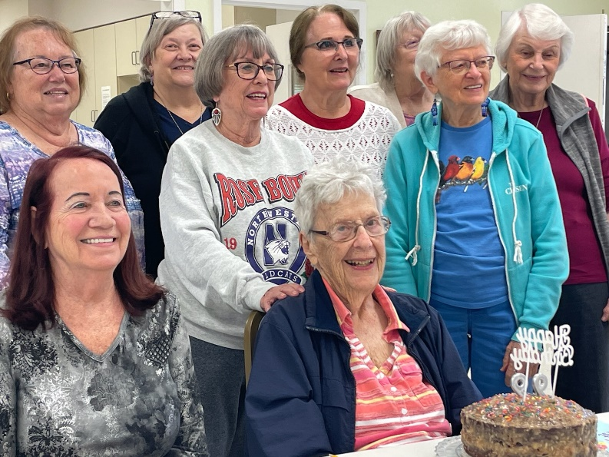

Our beautiful Nancy Westley will turn 99 years young on May 6. The Monday quilters took the opportunity to celebrate with Nancy early and enjoyed a party with her on April 24.

**FROM THE QUILTING MINISTRY**

From the Daily family. Thank you so much for the beautiful quilts. We can feel the love and kindness with your prayer. This was very thoughtful of everyone to participate. Please tell everyone thanks again. Paul and Mary Ann Daily

From Pete McCreedy. Dear church members and quilt makers. Thank you for the beautiful quilt you sent me. Your thoughtfulness and kindness were so welcomed during my recovery from spine surgery. I have the quilt in my office and when I look at it, I think of the wonderful people who blessed it and made it. Thanks again. Love, Pete McCreedy.

5

If you recognized our April cover girl was Breland Johnson, granddaughter of Kevin and Lisa Johnson, you were correct!

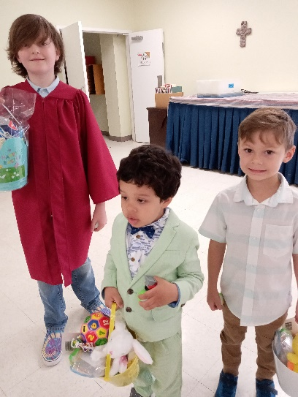 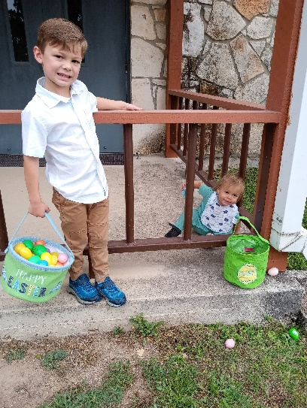 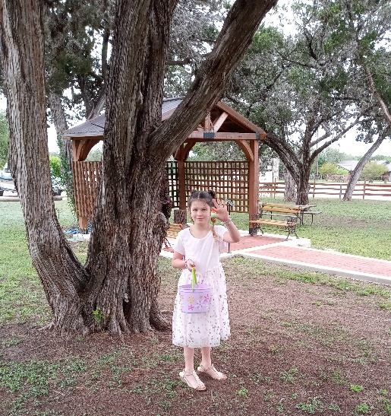

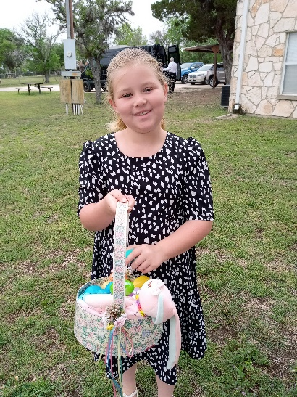 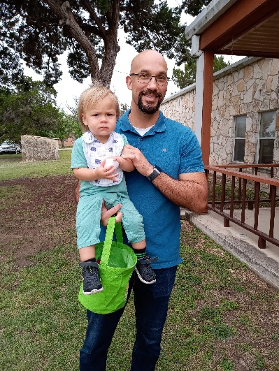 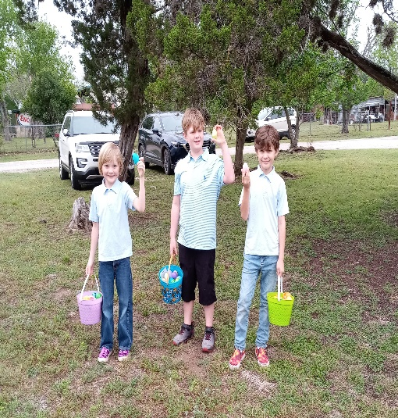

It was a picture-perfect day for our Easter egg hunt on April 9. I don’t know who had the most fun – the Easter bunny hiding the eggs or the kids who found them!

A friendly reminder – please take out the trash when you’re finishing an event in Fellowship Hall. And as always, turn out the lights and lock up both the porch doors and the kitchen door. Thank you!

PCPC Directory Update: Duane and Jackie’s address changes effective May 2. Please change it to 2005 Grand Loop, Boerne TX 78006

6