2023
PIPE CREEK PIPELINE
News, notes, and updates about our church family

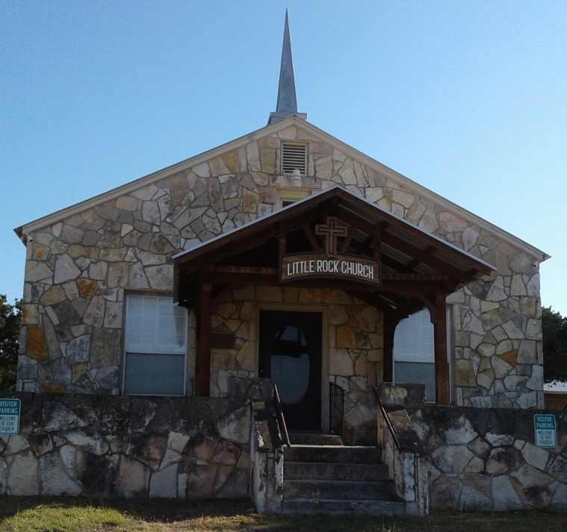
From the Pastor’s Pen…
December is a month of many different activities and emotions leading up to Christmas. We gather for worship each week while we wait for the birth of our Savior. While we wait, there are many activities to enjoy and remind us of the beauty and magic of this season. Little Rock Café will continue on December 6th and 20th. The Walk through Bethlehem will be at the Lakehills Community Center on December 16th from 6pm – 8pm. Our children will join children from throughout the county as they present “The Three Trees” story to celebrate Christmas. We will gather for our traditional candlelight service on Christmas Eve to hear the account of the birth of the Baby Jesus, the Messiah, Wonderful Counselor, Mighty God, Everlasting Father, and Prince of Peace. May you be filled with the wonder of this season and experience the Love of God through the birth of our Lord and Savior. I wish you and your family a very Merry Christmas! God be with you always! Duane Manning

8589 Highway 16 South, P.O. Box 63377, Pipe Creek TX 78063 830-510-6650
Sunday School 9:30 am Worship 10:30 am

DECEMBER SCRIPTURE PASSAGES

December 3 – Psalm 80: 1 – 7, 17 – 19; Mark 13: 24 - 37

December 10 – Isaiah 40: 1 - 11, Mark 1: 1 – 8

December 17 – Isaiah 61: 1 – 4, 8 - 11; 1 Thessalonians 5: 16 - 24

December 24 – Psalm 89: 1 – 4, 19 – 26; Luke 1: 26 - 38

December 24 (Christmas Eve)– Isaiah 9 – 2 - 7; Luke 2: 1 – 20

December 31 – Psalm 148; Luke 2: 22 – 40

Theme for the Month: Preparing for the Birth of Our Savior
December 3rd is the first Sunday of Advent with a theme of Hope. Our reading in Mark reminds us that the “Eternal Hope” of salvation should take priority in our minds from the daily world we live in. The theme for the second Sunday is Peace. In this Advent season we will include readings from the Prophet Isaiah. On December 10th, we read of the “Comfort for God’s People” in Isaiah 40. The third Sunday of Advent’s theme is “Joy”. The Apostle Paul writes to the Thessalonians, “Be joyful always; pray continually; give thanks in all circumstances, for this is God’s will for you in Christ Jesus.” That’s awesome advice for our daily lives! December 24th is the 4th Sunday of Advent in the morning and Christmas Eve in the evening. The theme in the morning is Love and we will experience Love during our candlelight service in the evening. On December 31st we hear from Simeon and Anna in the Synagogue as the Baby Jesus is presented in the Temple by his parents. Let us worship God together this month! Peace & Blessings.

LUNCH BUNCH BREAKS IN DECEMBER
With all of the holiday gatherings and activities, PCPC’s Lunch Bunch is taking a break in December. Look for this space in the January Pipeline for location for Lunch Bunch then. (See picture on page 6.)
For your future planning, Lunch Bunch gathers each month at a nearby restaurant. If you would like to suggest a restaurant for the group, give Barbara Boalo the details at 830-328-8009.
2
DECEMBER BIRTHDAYS
12/1 Bill Bowie
Donna Hannah
12/3 John Schuetze
12/6 Irene Smith
12/13 Tahmar Rasmussen
Sibby Melton
12/16 Yvonne McPherson
12/23 Michael Kelley
Lorna Wilson
12/31 Barbara Savary

CALENDAR OF EVENTS
DECEMBER
Dec 4 Children’s Choir Rehearsal, 4:30p
Dec 6 Little Rock Café, 5:30p
Dec 8 Russell Bowie lunch following his
memorial service in Bandera, 12:30p
Dec 11 Children’s Choir Rehearsal, 4:30p
Dec 16 ‘The Three Trees’ Performance, Walk Thru Bethlehem, Lakehills, 6:30p
Dec 20 Little Rock Café, 5:30p

3
SESSION RECAP…
From October and November meetings…
Jan Fuger joined the Church Triumphant on September 5. Her Cselebration of Life Service was held Oct 7 with Pastor Duane officiating.
Margo Begy requested transfer of her membership from PCPC to Highland Park Presbyterian Church, Winston-Salem NC. Session approved.
Regarding renovating/replacing the picnic tables, Session agreed to hold off until after the winter months to consider the best option.
Rhonda Smith, with the assistance of the Finance Committee, is working on the stewardship campaign results. Using those results, plus the inputs from the elders for the 2024 budget, PCPC’s congregation will have the 2024 budget figures presented at the Annual Congregational Meeting in January.
At the November 12 Called Congregational Meeting, Michael Kelley, Tahmar Rasmussen, and Barbara Boalo were elected to serve on the 2024 Representative Nominating Committee (RNC). They will present the names of the prospective elder candidates at the Annual Congregational Meeting in January.
Chris Kelley asked about poinsettias for the sanctuary this year. They are available for purchase ($8 each, order blanks are in each Sunday’s bulletin) to be delivered and displayed on December 10, 17, and 24. Those purchasing poinsettias can take them home on the 24th.

CHRISTMAS JOY OFFERING
The Christmas Joy Special Offering provides assistance to current and retired church workers and their families in their time of need. It also develops our future leaders at Presbyterian-related schools and colleges equipping communities of color.
Offering envelopes are in the pew racks and in Fellowship Hall. You may make your offering during the Advent or Christmas Season.
Please give what you can, for when we all do a little, it adds up to a lot
4
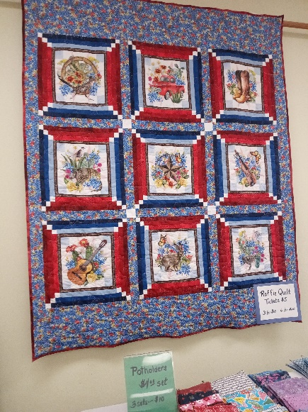
RAFFLE QUILT When you’re in Fellowship Hall, check out the quilt hanging on the wall. It’s being raffled by the Quilters and it’s a beaut!! It’s queen size – a very popular size. Tickets are $5 each or three for $10. Don’t miss out on your chance to own this one-of-a-kind lovely quilt when we pull the winning ticket, probably in January.

TRUNK OR TREAT, 2023
We had fun on Halloween, October 31, in the PCPC parking lot when we celebrated Trunk or Treat. Hot dogs and chips were provided, and the weather was great.

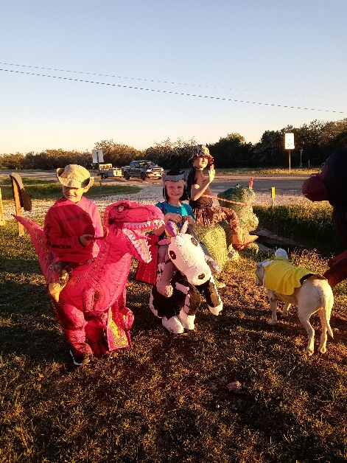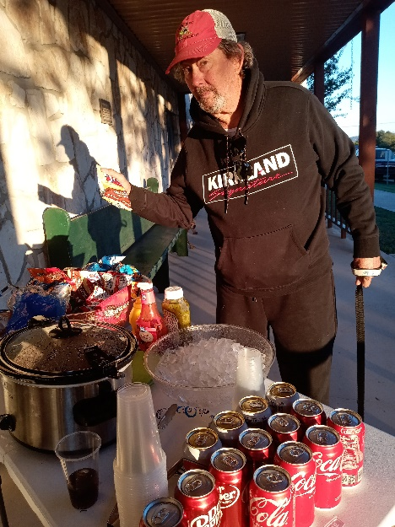
The Weller kids and Joel Price’s dog welcomed passers-by and encouraged them to stop in. Kirk Price got caught enjoying a bag of chips and hot dog on the Fellowship Hall porch.

5
A THANK YOU…
Thank you so much for your much needed prayers. We are finding our strength through them. Your thoughtfulness through your prayer quilts have brought comfort to our family during this difficult time.
Love, The Hicks Family
* * * * * * *
It is with appreciation and gratefulness that we write to say a special thank you for the two wonderful prayer quilts you sent to us this year. We have both been blessed by the multitude of prayers offered for health and well being this year.
God surely has been at work in our lives with the many friends, family, and fellow Christians around the country.
Your quilts are tangible reminders of how none of us struggles through difficult times alone. May God bless each and every hand that tied knot, stitched a stitch, and prayed over them.
We are both doing better now and will continue to share the mission and purpose for the quilts “to share the joys and comfort of God’s love and the message of reconciliation through Jesus Christ.”
Thank you for your labor of love and thoughtfulness,
Harold “Budy” and Martha Clark
* * * * * * *
My name is Linda Eaton, I’m Jan Fuger’s cousin. Still recovering from the news that she’s gone, really going to miss her…..Thank you for being there for Jan. Sincerely, Linda Eaton
* * * * * * *
Thank you for the beautiful quilt. Your thoughts and prayers are appreciated during these times. Many thanks to the congregation thinking and praying for my wife and family. Jim Abele

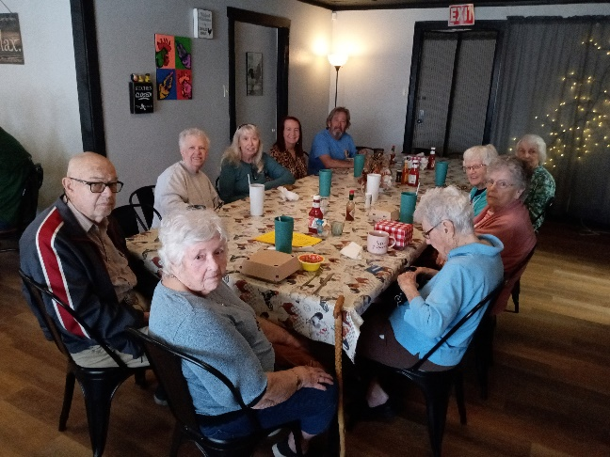
LUNCH BUNCH enjoyed the Hen’s Nest in Bandera at their November 17 gathering. Nancy Westley originally suggested it and it’s proven to be a favorite of the group. Join us for our January outing – wherever that may be!

6

